

IntelliMeet Pro: AI Meeting Assistant & Workflow Management

PROJECT SUPERVISOR
Syeda Rubab Jaffar

PROJECT TEAM
Mustafa Masood 22k-4818
Laiba Fatima 22k-5195

FAST SCHOOL OF COMPUTING
NATIONAL UNIVERSITY OF COMPUTER AND EMERGING SCIENCES KARACHI CAMPUS
Spring 2026

Project Supervisor | Syeda Rubab Jaffar
Project Team | Mustafa Masood K22-4818  Laiba Fatima K22-5195
Submission Date | May 10, 2026

Syeda Rubab Jaffar 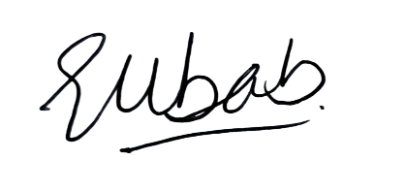

Supervisor

Abstract

IntelliMeet Pro addresses the growing challenge of managing and utilizing information generated during online meetings. Traditional note-taking methods are often inefficient, error-prone, and unable to effectively capture decisions, action items, and key discussion points. With the increasing adoption of remote collaboration platforms such as Google Meet organizations require intelligent solutions that can transform meeting conversations into structured, actionable knowledge.

This project proposes the development of an AI-powered meeting assistant that automates transcription, meeting summarization, speaker identification, and workflow management. IntelliMeet Pro uses advanced Natural Language Processing (NLP), speaker diarization, and Retrieval-Augmented Generation (RAG) techniques to generate searchable transcripts, extract tasks and decisions, and provide semantic search across meeting histories. The system further enhances productivity through integrations with project management platforms including Jira, Trello, and Asana, as well as conversational Slack bot support for querying past meetings.

The proposed solution also includes real-time calendar synchronization, transcription, and secure cloud-based storage for collaboration and accessibility. By bridging the gap between communication and execution, IntelliMeet Pro minimizes manual effort, reduces information loss, and improves coordination among teams. The project contributes to modern AI-driven collaboration systems by combining intelligent meeting understanding with workflow automation, ultimately enabling organizations to achieve more efficient and productive digital teamwork.

Table of Contents

1. Introduction 6
1.1 Problem Statement 6
1.2 Proposed Solution 6
1.3 Project Objective 6
1.4 Intended Audience 7
1.5 Document Convention 7
2. Related Work 8
3. Requirements 10
3.1 Functional Requirements 10
3.2 Non-Functional Requirements 13
3.3 Excluded Functionalities 14
4. Design 1
4.1 System Level Architecture 16
4.2 Software Architecture 17
4.3 System Flow 18
4.4 Database ER Design 18
4.5 Class Diagram 19
4.6 Data Dictionary 20
4.6.1 Users 20
4.6.2 Workspaces 21
4.6.3 Meetings 22
4.6.4 Transcripts 23
4.6.5 Summaries 24
4.6.6 Action Items 25
4.6.7 Speaker Profiles 26
4.6.8 Integrations 27
4.6.9 Subscriptions 28
4.7 Use Case Diagram 29
4.7.1 Use Case Descriptions 34
4.8 Sequence Diagram 50
4.8.1 User Registration + User Login 50
4.8.2 Create Workspace & Invite Members 51
4.8.3 Schedule Meeting with AI Bot 52
4.8.4 Transcript + Summary 53
4.8.5 Semantic Search 54
4.8.6 Action items sync with PM tool (Jira Sync) 55
4.8.7 Query Meeting Content via Slack Bot 56
4.9 State Diagram 57
4.9.1 Authentication & Account Lifecycle 57
4.9.2 Meeting Processing Lifecycle 58
4.9.3 RAG Semantic Search Flow 59
4.9.4 Workspace & RBAC Flow 60
4.9.5 Payment & Subscription Lifecycle 61
4.10 Data Flow Level 1 Diagram 62
5. Implementation 63
6. Testing and Evaluation 64
7.Conclusion 67
8. References 68
9. Appendices 71

Introduction
1.1 Problem Statement
Team collaboration and meetings are an essential part of any organisation, but they are challenging to organise and manage [10]. With the rise in geographically dispersed teams, the COVID-19 pandemic, and shift towards remote work, organizations are increasingly adopting online web conferencing tools to hold meetings [1, 2]. Organizations that use online meeting platforms like Google Meet generate a considerable amount of conversational data that contains critical business intelligence, project updates, and strategic decisions. Unfortunately, most of this information is not used because of the absence of tools that are able to record, structure, and transform discussions into actionable items. Traditional practices for capturing meeting content, such as paper and electronic note-taking, are often informal and burdensome on meeting participants [3].
1.2 Proposed Solution
IntelliMeet Pro is an AI-powered meeting automation platform that seamlessly joins virtual meetings, transcribes discussions with accurate speaker identification, generates concise summaries, extracts action items with assigned owners, and syncs tasks across tools like Jira, Trello, and Asana. It stores all meeting data in a searchable vector database and provides a conversational Slack bot interface, enabling teams to instantly retrieve insights, track decisions, and convert discussions into actionable, persistent organizational knowledge.

1.3 Project Objective
The objective of IntelliMeet Pro is to design and develop an intelligent meeting assistant that makes use of natural language processing (NLP) to transcribe, analyze, and summarize meeting conversations. IntelliMeet Pro will not only provide searchable transcripts but also extract decisions, assign tasks, and integrate them with popular project management tools to ensure continuity across meetings.
To achieve this, the project will be divided into sub-tasks such as speech-to-text transcription, speaker diarization for persistent identification, semantic summarization of discussions, and integration with tools like Jira, Trello, and Slack. Techniques such as transformer-based NLP models, semantic search algorithms, and real-time API integrations will be adopted.
The success of the project will be measured using criteria such as transcription accuracy, relevance of extracted decisions, efficiency of task integration, and user satisfaction in improving meeting productivity. By meeting these goals, the system will bridge the gap between communication and execution, ultimately enabling teams to collaborate more effectively in digital workspaces.

1.4 Intended Audience
- FAST National University: Academic institution sponsoring and evaluating this Final Year Project
- Jury Members: Academic evaluators assessing project scope, technical rigor, and implementation quality
- Project Supervisor (Ms. Rubab Jaffar): Primary advisor providing guidance and evaluating project progress
- Development Team (Mustafa Masood, Laiba Fatima): Software engineers responsible for system design, implementation, testing, and deployment
- Potential End Users: Organizations, teams, and professionals who will utilize IntelliMeet Pro for meeting management

1.5 Document Convention
- Font Family = Georgia
- Font Size = 16 for headings, 14 for subheadings, 12 for the rest of the content

2. Related work
Existing research on AI-assisted meeting understanding has advanced in transcription, summarization, and workflow integration, but key gaps remain. LLM-powered recap systems from Microsoft and HCI studies demonstrate that structured highlights and hierarchical minutes improve recall and coordination [13]. Benchmark datasets such as MeetingBank [16] and MUG [17] enable supervised training for summarization and action detection, though they lack evidence-linked outputs. Real-time pipelines now achieve sub-200 ms transcription [18] and online summarization policies balance latency and quality [19], yet most omit persistent diarization and automated meeting participation.
Advances in diarization through multimodal challenges [20] and multi-agent systems for task extraction [21] show promise but remain limited in long-term speaker stability, structured action extraction, and bidirectional project management integration. Although recent systems have improved scalability and transcription accuracy, current solutions still struggle to provide grounded, context-aware, and enterprise-ready workflow automation.
Several research prototypes have attempted to bridge these gaps. For example, TalkTraces maps discussion content to meeting agendas in real time [4], while MeetScript provides collaborative live transcripts that participants can annotate to improve meeting comprehension [5]. However, prior studies indicate that excessive real-time assistance can increase cognitive load, as users must simultaneously process transcripts, summaries, and visualizations during meetings.
Commercial platforms have also introduced AI-powered meeting assistants with varying levels of automation and collaboration support. Otter.ai is widely recognized for its real-time transcription, speaker identification, and live collaborative notes. The platform provides automated summaries and searchable transcripts but offers limited semantic retrieval and restricted workflow automation outside its native ecosystem. In addition, its action item extraction remains largely keyword-driven, which reduces contextual understanding in long and complex meetings.
Fireflies.ai focuses heavily on enterprise integrations and meeting analytics. The platform supports automated note-taking, calendar synchronization, and integrations with collaboration tools such as Slack and Jira. While effective for basic workflow automation, it often struggles in meetings with overlapping speakers, rapid topic switching, and noisy environments. Furthermore, its action item generation lacks deeper contextual linking between discussions, assigned tasks, and historical meeting references.
ClickUp AI integrates meeting documentation directly within a broader project management environment. It combines note generation, task creation, and collaboration features into a unified workspace. However, its AI meeting capabilities are primarily supplementary to the project management platform itself and lack advanced conversational querying, persistent speaker profiling, and intelligent retrieval across historical meetings.
Sembly AI provides automated meeting transcription, summaries, and task extraction with support for cloud-based collaboration. The system emphasizes productivity reporting and post-meeting insights but offers limited automation for joining meetings and lacks persistent conversational memory between sessions. Its speaker diarization also becomes less reliable in large multi-speaker discussions.
Other platforms such as Avoma, Fathom, MeetGeek, and Supernormal provide combinations of meeting summaries, CRM synchronization, and collaboration support. However, most existing systems primarily focus on transcription and summarization rather than long-term knowledge management. Many platforms generate static summaries without enabling advanced semantic search, evidence-grounded retrieval, or conversational interaction with previous meetings.
A major limitation across current commercial solutions is the absence of persistent meeting intelligence. Existing tools generally treat meetings as isolated sessions instead of connected organizational knowledge assets. As a result, users face difficulties retrieving past decisions, tracking recurring action items, and understanding discussion continuity across teams and projects. Moreover, many systems rely on basic keyword matching instead of Retrieval-Augmented Generation (RAG) architectures for contextual retrieval.
IntelliMeet Pro differentiates itself through several architectural and functional innovations designed to address these limitations. The proposed system introduces persistent voice identification across meetings to build reusable speaker profiles and improve long-term diarization consistency. Unlike conventional keyword-based retrieval systems, IntelliMeet Pro utilizes a Retrieval-Augmented Generation (RAG) pipeline with Pinecone vector storage to enable semantic search and evidence-aware conversational querying over historical meetings.
The system also extends beyond transcription by integrating intelligent workflow orchestration. Through native Slack bot support and project management synchronization, extracted action items can be automatically converted into tasks and distributed across platforms such as Jira, Trello, and Asana. Additionally, IntelliMeet Pro supports automated meeting participation through bot joining, calendar synchronization, collaborative workspace management and encrypted storage.
Compared to existing systems, IntelliMeet Pro aims to combine real-time meeting assistance, long-term organizational memory, semantic retrieval, and workflow automation within a unified architecture. This combination addresses critical gaps in current research and commercial platforms by transforming meeting data into a persistent, searchable, and actionable knowledge base rather than static transcripts and summaries.

3. Requirements

3.1 Functional Requirements
The functional capabilities of IntelliMeet Pro are organized into a hierarchical structure representing the system's major functional areas and sub-functions:
- User Management
1.1 User Registration and Authentication
1.1.1 Account Creation
1.1.2 Email Verification
1.1.3 Secure Login
1.1.4 Password Reset
1.2 User Profile Management
1.2.1 Update Personal Information
1.2.2 Change Password
- Workspace Management
2.1 Workspace Creation and Configuration
2.1.1 Create New Workspace
2.1.2 Define Workspace Settings
2.1.3 Configure Integration Defaults
2.2 Member Management
2.2.1 Invite Members via Email
2.2.2 Assign User Roles
2.2.3 Remove Members from Workspace
2.2.4 Modify Member Roles
2.3 Workspace Permissions
2.3.1 Enforce Role-Based Access Control
2.3.2 Control Meeting Visibility
2.3.3 Manage Data Access Permissions
- Meeting Bot Deployment and Recording
3.1 Calendar Integration
3.1.1 Sync with Google Calendar
3.1.2 Manual Meeting Entry
3.2 Automatic Bot Deployment
3.2. 1 Join Google Meet Sessions
3.3 Audio Recording
3.3.1 Capture High-Quality Audio
3.3.2 Upload Recordings to Azure Blob Storage
3.3.3 Handle Recording Failures
3.4 Connection Management
3.4.1 Maintain Stable Bot Connections
3.4.2 Auto-reconnect on Network Disruption
3.4.3 Graceful Exit on Meeting End
- Transcription and Speaker Diarization
4.1 Speech-to-Text Conversion
4.1.1 Submit Audio to Whisper API
4.1.2 Receive Timestamped Transcripts
4.1.3 Handle Transcription Errors
4.2 Speaker Identification
4.2.1 Perform Speaker Diarization
4.2.2 Create Persistent Voice Profiles
4.2.3 Match Speakers Across Meetings
4.2.4 Allow Manual Speaker Corrections
4.3 Transcript Management
4.3.1 Store Transcripts in Database
4.3.2 Display Transcripts with Speaker Labels
- AI-Powered Summarization and Insights
5.1 Meeting Summary Generation
5.1.1 Analyze Complete Transcripts
5.1.2 Generate Executive Overview
5.1.3 Extract Key Discussion Points
5.1.4 Identify Decisions Made
5.2 Action Item Extraction
5.2.1 Identify Actionable Tasks
5.2.2 Attribute Tasks to Participants
5.3 Summary Presentation
5.3.1 Display Structured Summaries
5.3.2 Support Summary Export
5.3.3 Send Calendar Notifications
- Semantic Search and Knowledge Retrieval
6.1 Vector Embedding Generation
6.1.1 Generate Embeddings for Transcripts
6.1.2 Store Embeddings in Pinecone
6.1.3 Index Metadata for Filtering
6.2 Search Query Processing
6.2.1 Accept Natural Language Queries
6.2.2 Convert Queries to Embeddings
6.2.3 Perform Similarity Search
6.2.4 Return Ranked Results
6.3 Search Result Presentation
6.3.1 Display Contextual Excerpts
6.3.2 Highlight Matching Keywords
6.3.3 Provide Links to Full Transcripts
- Project Management Integration
7.1 Integration Configuration
7.1.1 Connect Jira Accounts
7.1.2 Connect Trello Accounts
7.1.3 Connect Asana Accounts
7.1.4 Configure Default Projects/Boards
7.2 Action Item Synchronization
7.2.1 Create Tasks in External Systems
7.2.2 Map IntelliMeet Pro Fields to External Fields
7.2.3 Sync Status Updates Bidirectionally
7.2.4 Handle Integration Errors
- Slack Bot Conversational Assistant
8.1 Bot Installation and Configuration
8.1.1 Install Bot to Slack Workspace
8.1.2 Link Slack Users to IntelliMeet Pro Accounts
8.1.3 Configure Bot Permissions
8.2 Query Processing
8.2.1 Receive User Messages
8.2.2 Parse Natural Language Intent
8.2.3 Retrieve Relevant Information
8.2.4 Send Formatted Responses
8.3 Slash Commands
8.3.1 /intellimeet search [query]
8.3.2 /intellimeet summary [meeting]
8.3.3 /intellimeet actions
8.3.4 /intellimeet help
8.4 Notification Delivery
8.4.1 Send Meeting Summary Notifications
8.4.2 Send Action Item Assignments
8.4.3 Allow Subscription Management
- Subscription and Payment Processing
9.1 Subscription Management
9.1.1 Display Subscription Tiers
9.1.2 Process Subscription Selection
9.1.3 Handle Upgrades and Downgrades
9.1.4 Process Cancellations
9.2 Payment Processing
9.2.1 Integrate Stripe Elements
9.2.2 Create Stripe Customers
9.2.3 Process Recurring Payments
9.2.4 Handle Payment Failures
9.3 Usage Tracking and Enforcement
9.3.1 Track Meeting Minutes Usage
9.3.2 Enforce Subscription Limits
9.3.3 Display Usage Metrics
9.3.4 Send Quota Warning Notifications
9.4 Billing and Invoicing
9.4.1 Generate Invoices
9.4.2 Send Email Receipts
9.4.3 Provide Billing History
- Multilingual Meeting Support
10.1 Multilingual Audio & Transcript Processing
10.1.1 Detect Spoken Language Automatically
10.1.2 Process Meetings in 99+ Languages
10.1.3 Support Multilingual Speech-to-Text Transcription
- Dashboard and Reporting
12.1 Meeting Dashboard
12.1.1 Display Upcoming Meetings
12.1.2 Show Recent Meetings
12.1.3 Highlight Pending Action Items
12.2 Analytics and Metrics
12.2.1 Display Meeting Statistics
12.2.2 Show Action Item Completion Rates
12.2.3 Track Subscription Usage
12.3 Meeting History
12.3.1 Browse Past Meetings
12.3.2 Filter and Sort Meetings
12.3.3 Access Archived Content

3.2 Non-Functional Requirements
These requirements define the quality standards and overall behavior expected from IntelliMeet Pro.
1. Performance:
The system should provide fast and responsive interactions for users, including smooth navigation, quick loading of meeting data, efficient transcription processing, and timely generation of summaries and search results. It should also support multiple concurrent users without significant performance degradation.
- Reliability:
The platform should operate consistently without crashes or major failures during meeting processing, transcription, or integrations with third-party services. Backup and recovery mechanisms should ensure that important meeting data is not permanently lost.
3. Security:
User accounts, meeting recordings, transcripts, and workspace data must be protected using secure authentication, authorization, and encrypted storage mechanisms. Access to sensitive information should be restricted to authorized users only.

4. Usability:
The system interface should be simple, intuitive, and easy to navigate for both technical and non-technical users. Features such as meeting summaries, transcripts, and task management should be clearly accessible and understandable.
5. Scalability:
The system should be capable of handling increasing numbers of meetings, transcripts, users, and integrations while maintaining stable performance and responsiveness.
6. Maintainability:
The application should follow a modular and organized architecture so that future updates, feature additions, and bug fixes can be implemented efficiently.
7. Availability:
The system should remain accessible and operational with minimal downtime, ensuring users can access meetings, transcripts, and collaboration features whenever needed.
8. Compatibility:
The platform should support integration with commonly used communication and project management tools such as Google Meet, Jira, Trello, Asana, and Slack.
9. Data Integrity:
Meeting transcripts, summaries, and action items should remain accurate, consistent, and synchronized across the system and connected third-party platforms.
10. Multilingual Support:
The system should support meetings and transcript processing in 99+ languages while properly handling multilingual conversations and different text orientations such as right-to-left languages.
3.3 Excluded Functionalities
The following functionalities are explicitly excluded from the current scope of IntelliMeet Pro:
- Real-Time Video Processing and Computer Vision
  - No video analysis or facial recognition features
  - No gesture detection or body language analysis
  - No screen sharing content analysis or OCR processing
- Mobile Application Development
  - No native iOS application development
  - No native Android application development
  - Web application is responsive but not optimized as native mobile experience
- Advanced Analytics and Business Intelligence
  - No comprehensive analytics dashboards beyond basic meeting metrics
  - No predictive analytics or trend analysis
  - No advanced reporting tools for organizational insights

- CRM and HRM System Integration
  - No integration with customer relationship management (CRM) systems
  - No integration with human resources management (HRM) platforms
  - No employee performance tracking or evaluation features
- Voice Synthesis and Text-to-Speech
  - No audio generation from text content
  - No voice cloning or synthesis capabilities
  - No automated voice responses in conversational interfaces
- End-to-End Encryption for Stored Data
  - Encryption in transit via TLS but not end-to-end encryption for stored transcripts
  - Standard database encryption at rest but not zero-knowledge architecture
  - Trade-off necessary to enable semantic search functionality
- Multi-Tenant White-Label Deployment
  - No white-label customization for third-party resellers
  - No multi-tenant architecture supporting isolated customer instances
  - Single-instance SaaS deployment model
- Advanced Workflow Automation Beyond Task Tracking
  - No complex workflow builder or automation engine
  - No conditional logic for task dependencies and triggers
  - Basic action item tracking without advanced project management features
- Advanced AI Training and Model Fine-Tuning
  - No custom AI model training on organization-specific data
  - No fine-tuning of language models for domain-specific terminology
  - Utilization of pre-trained models (OpenAI Whisper, GPT-4) without modification
- Real-Time Live Transcription Display During Meetings
  - Transcription processed post-meeting rather than displayed in real-time to participants
  - Focus on post-meeting intelligence rather than in-meeting assistance

4. Design
4.1 System Level Architecture

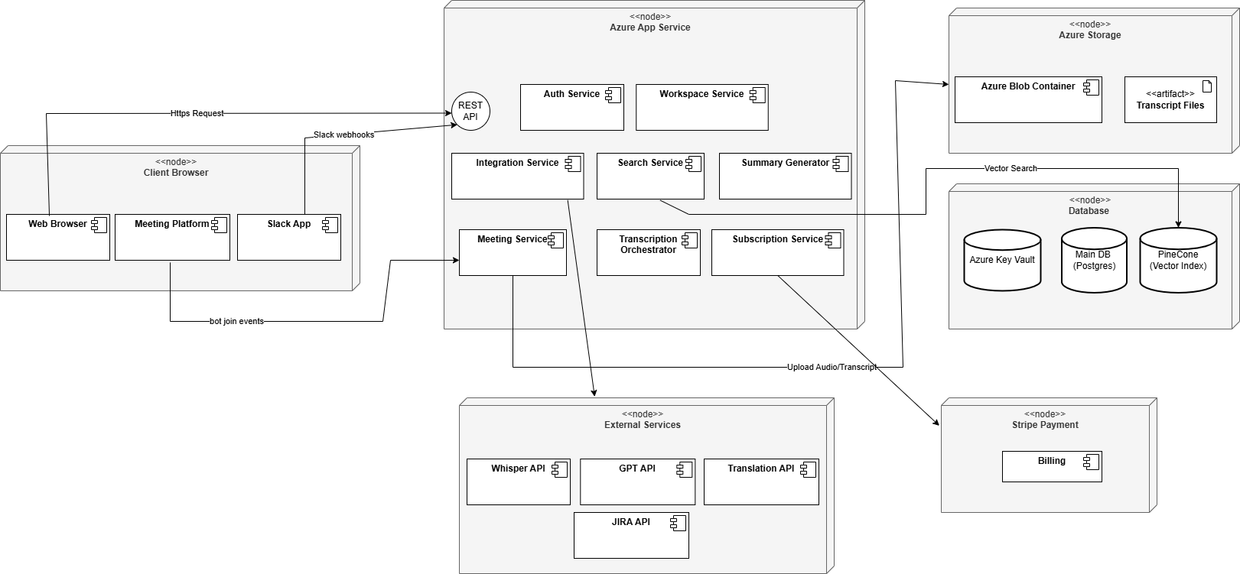
Figure 1. Deployment Diagram

This deployment diagram shows IntelliMeet Pro running through a client browser that communicates with a central Azure App Service hosting all backend services, including authentication, meetings, integrations, search, transcription orchestration, summarization, and subscriptions. The backend connects to Azure Storage for transcript files, a database cluster containing the main Postgres DB, Key Vault, and Pinecone vector index, and various external APIs such as Whisper, GPT, Translation services, Jira, and conferencing platforms. Stripe Payment handles billing and subscription processing, completing the system's external integrations.

4.2 Software Architecture
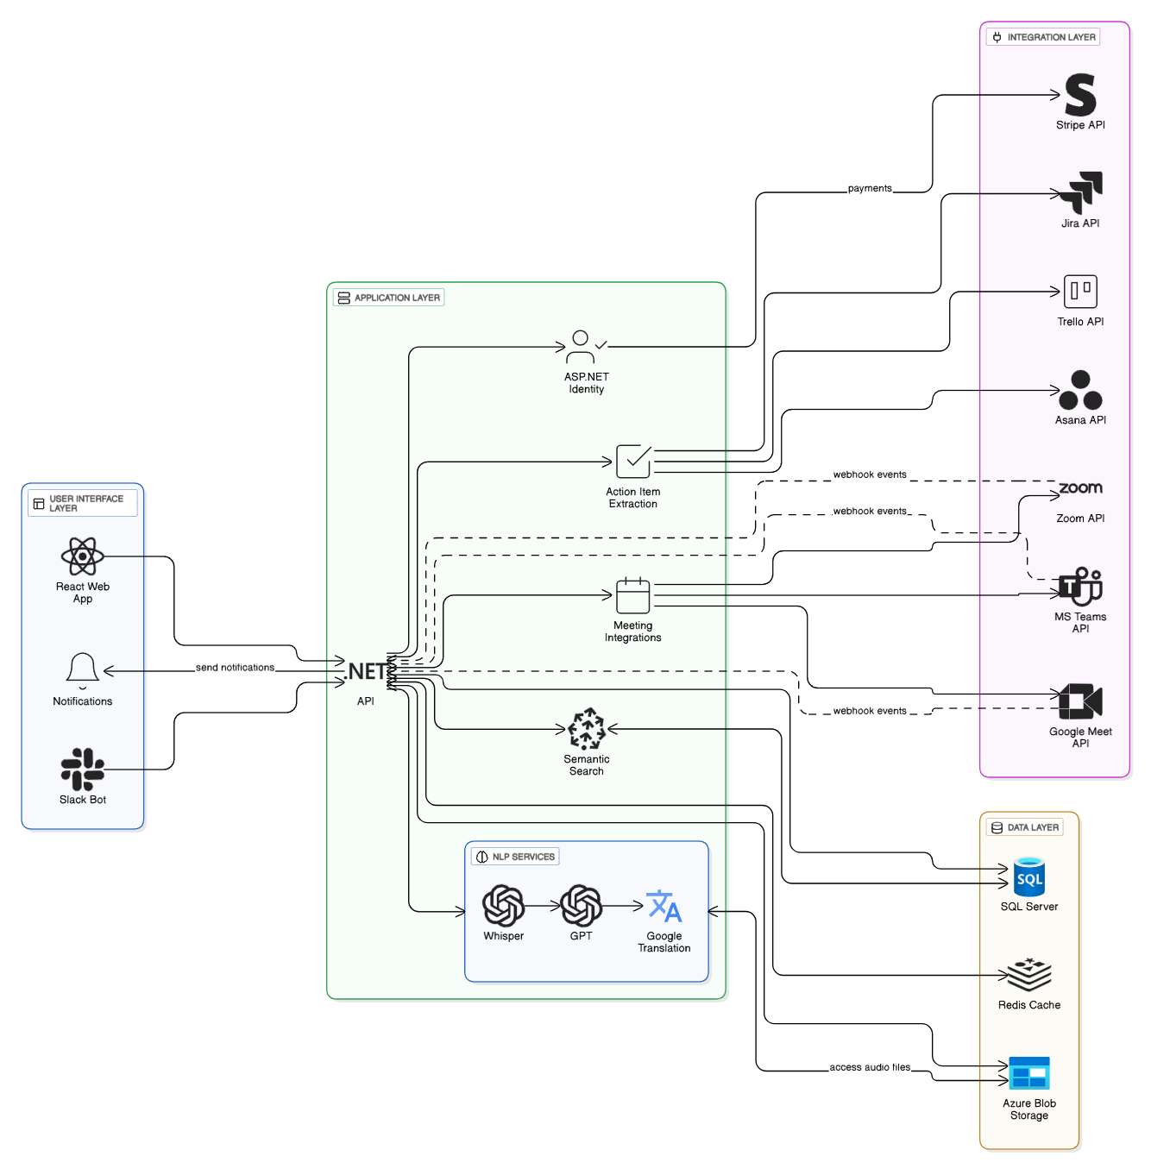
Figure 2. Architecture Diagram
This architecture diagram illustrates the layered design of IntelliMeet Pro, where the User Interface layer (React Web App, Slack Bot, Notifications) interacts with the central .NET API, which serves as the system’s orchestrator. The Application Layer handles authentication, meeting integrations, action item extraction, semantic search, and webhook processing, while the NLP Services layer provides AI-powered capabilities such as Whisper transcription and GPT summarization. The Data Layer stores structured data in SQL Server, caches sessions in Redis, and saves audio files in Azure Blob Storage. Finally, the Integrations Layer connects the system to external services including Stripe for payments, Jira/Trello/Asana for task synchronization, and Zoom/Meet/Teams for meeting automation, enabling seamless communication through secure API calls and webhooks.
4.3 System Flow
A typical system interaction proceeds as follows:
- The Presentation Layer captures a user action (e.g., scheduling a meeting or querying past transcripts).
- The request is processed by the Application Layer, where business logic determines workflows such as joining a meeting, processing audio, or generating a summary.
- The Application Layer retrieves or stores necessary data via the Data Layer.
- If external services are required (e.g., Slack query, Jira integration, or Stripe subscription validation), the Application Layer communicates with the Integration Layer, which handles the API calls.
- Results are propagated back up to the Presentation Layer, ensuring seamless user interaction.

4.4 Database ER Design
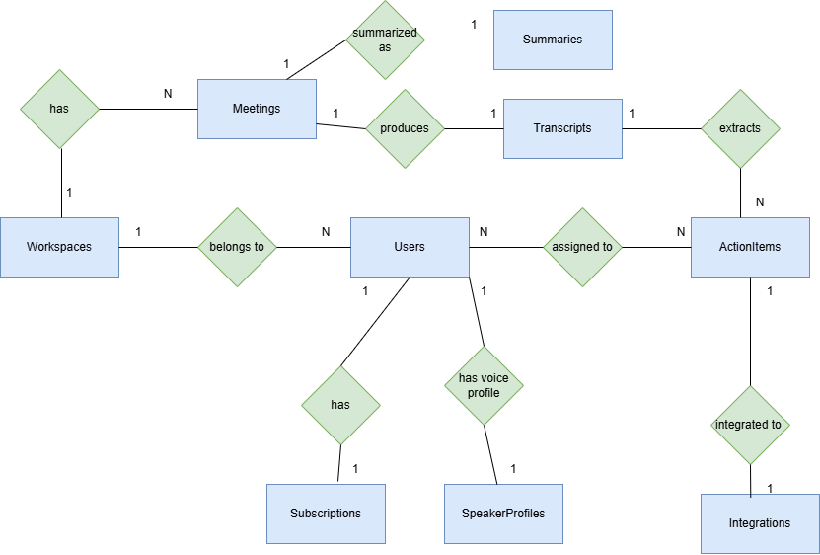
Figure 3. ER Diagram

4.5 Class Diagram
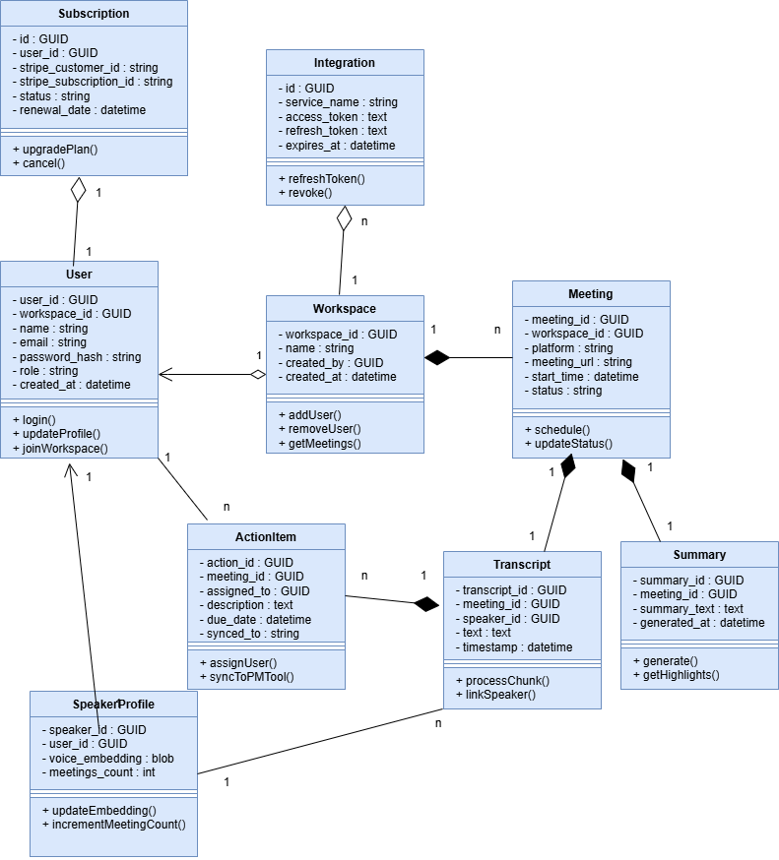
Figure 4. Class Diagram

Data Dictionary

Users

Users
Name | The user that will use our product
Alias | User
Where-used/how-used | Users represent all individuals who log into IntelliMeet Pro, including workspace owners (admins) and members. They authenticate through the system using email/password, receive verification emails, join workspaces, and perform actions such as querying transcripts, generating summaries, reviewing tasks, and receiving Slack responses.
Content description | Stores profile, credentials, workspace association, and authorization roles.

Table 1. Users
Column | Description | Type | Length | Nullable | Default value | Key
user_id | unique identifier | GUID | 36 | No | None | PK
workspace_id | FK to workspace | GUID | 36 | No | None | FK
name | Full name | varchar(256) | 256 | No | None | -
email | unique email | varchar(256) | 256 | No | None | Unique
password_hash | hashed password | varchar(512) | 512 | No | None | -
role | Admin / Member | varchar(50) | 50 | No | None | -
created_at | timestamp | datetime | - | No | Current timestamp | -

Workspaces

Workspaces
Name | The workspace area created for user to manage meetings
Alias | Organizations / Teams
Where-used/how-used | A workspace groups users, meetings, transcripts, and summaries under one collaborative entity. Every user belongs to a workspace, and all meetings, integrations, and permissions derive from workspace ownership. Admins manage members, authorize Slack + PM integrations, and control settings.
Content description | Stores high-level grouping for accounts and meeting data.
Table 2. Workspaces
Column | Description | Type | Length | Nullable | Default value | Key
workspace_id | unique id | GUID | 36 | No | None | PK
name | workspace name | varchar(256) | 256 | No | None | -
created_by | owner | GUID | 36 | No | None | FK
created_at | timestamp | datetime | - | No | Current timestamp | -

Meetings

Meetings
Name | Meetings of a user
Alias | Meeting
Where-used/how-used | Represents scheduled meetings that the IntelliMeet Pro bot must join at the specified time. Used during scanning, bot joining, transcription, diarization, summary generation, action item creation, and semantic search indexing.
Content description | Metadata for scheduled and completed meetings.
Table 3. Meetings
Column | Description | Type | Length | Nullable | Default value | Key
meeting_id | meeting id | GUID | 36 | No | None | PK
workspace_id | FK | GUID | 36 | No | None | FK
platform | Zoom/Meet/Teams | varchar(50) | 50 | No | None | -
meeting_url | join link | varchar(512) | 512 | No | None | -
start_time | scheduled time | datetime | - | No | None | -
status | scheduled/ongoing/completed | varchar(50) | 50 | No | None | -

Transcripts
Transcripts
Name | Written record of every meeting
Alias | Transcripts
Where-used/how-used | Stores the audio-to-text output from Whisper API along with diarization results. Used for RAG search, summary generation, Slack Q&A, action item extraction, and semantic search embedding.  Each chunk is tied to a meeting and may link to a speaker profile.
Content description | Contains processed transcript chunks with timestamps and speaker attribution.

Table 4. Transcripts
Column | Description | Type | Length | Nullable | Default value | Key
transcript_id | PK | GUID | 36 | No | None | PK
meeting_id | FK | GUID | 36 | No | None | FK
speaker_id | diarized speaker | GUID | 36 | Yes | None | FK
text | transcript text | TEXT | - | No | None | -
timestamp | chunk time | datetime | - | No | None | -

Summaries

Summaries
Name | Performance stats for the employee
Alias | AI-Generated Meeting Summary
Where-used/how-used | Created automatically after a meeting ends. GPT uses transcript and embeddings to produce high-level summaries and action items. These summaries appear on dashboards, Slack summaries, PM tool syncing, and semantic search.
Content description | Stores generated summaries with timestamps.

Table 5. Summaries
Column | Description | Type | Length | Nullable | Default value | Key
summary_id | summary id | GUID | 36 | No | None | PK
meeting_id | FK | GUID | 36 | No | None | FK
summary_text | text | TEXT | - | No | None | -
generated_at | datetime | No | - | No | None | -

Action Items

ActionItems
Name | The tasks extracted from transcription
Alias | Action Items
Where-used/how-used | Generated by the summary engine and synced with Jira, Trello, Asana. Used to track responsibilities, deadlines, and action follow-up.
Content description | Stores actionable tasks extracted from meetings.

Table 6. Action Items
Column | Description | Type | Length | Nullable | Default value | Key
action_id | item id | GUID | 36 | No | None | PK
meeting_id | FK | GUID | 36 | No | None | FK
assigned_to | user | GUID | 36 | Yes | None | -
description | text | TEXT | - | Yes | None | -
due_date | Due date | datetime | - | Yes | None | -
synced_to | Jira/Trello/Asana | varchar(50) | 50 | Yes | None | -

Speaker Profiles

SpeakerProfiles
Name | Identity of each speaker/user
Alias | Voice Identity Records
Where-used/how-used | Used to improve diarization accuracy by maintaining speaker embeddings.  The system can map recurring voices to users, improving accuracy over multiple meetings.  Supports features like identifying unknown speakers and building speaker statistics.
Content description | Stores voice embeddings and optional links to existing users.

Table 7. Speaker Profiles
Column | Description | Type | Length | Nullable | Default value | Key
speaker_id | speaker profile | GUID | 36 | No | None | PK
user_id | optional link | GUID | 36 | Yes | None | FK
voice_embedding | vector | blob | - | No | None | -
meetings_count | Number of meetings spoken in | int | - | No | None | -

Integrations

Integrations
Name | Integrations
Alias | Connected Accounts / OAuth Tokens
Where-used/how-used | Stores tokens and configuration for external services: Slack bot authentication, Zoom/Meet/Teams bot access, Jira / Trello / Asana OAuth tokens
Content description | Stores encrypted integration credentials and metadata.

Table 8. Integrations
Column | Description | Type | Length | Nullable | Default value | Key
id | record id | GUID | 36 | No | None | PK
service_name | Jira/Slack/Asana/etc. | varchar(100) | 100 | No | None | -
access_token | OAuth token | TEXT | - | No | None | -
refresh_token | refresh token | TEXT | - | Yes | None | -
expires_at | expiry time | datetime | - | Yes | None | -

Subscriptions

Subscriptions
Name | The selected plan of each user
Alias | Billing / Stripe Records
Where-used/how-used | Tracks paid plans, subscription tiers, and Stripe billing sessions. Used for restricting feature access (e.g., number of meetings/month).
Content description | Stores subscription details returned by Stripe.

Table 9. Subscriptions
Column | Description | Type | Length | Nullable | Default value | Key
id | subscription id | GUID | 36 | No | None | PK
user_id | FK to user | GUID | 36 | No | None | FK
stripe_customer_id | Stripe customer | varchar(200) | 200 | No | None | -
stripe_subscription_id | Stripe subscription | varchar(200) | 200 | No | None | -
status | active/canceled | varchar(50) | 50 | No | None | -
renewal_date | datetime | - | - | No | none | -

Use Case Diagram
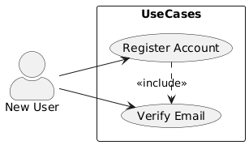
Figure 5. New User
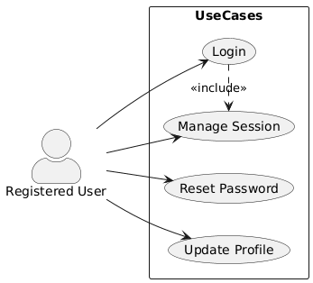
Figure 6. Registered User
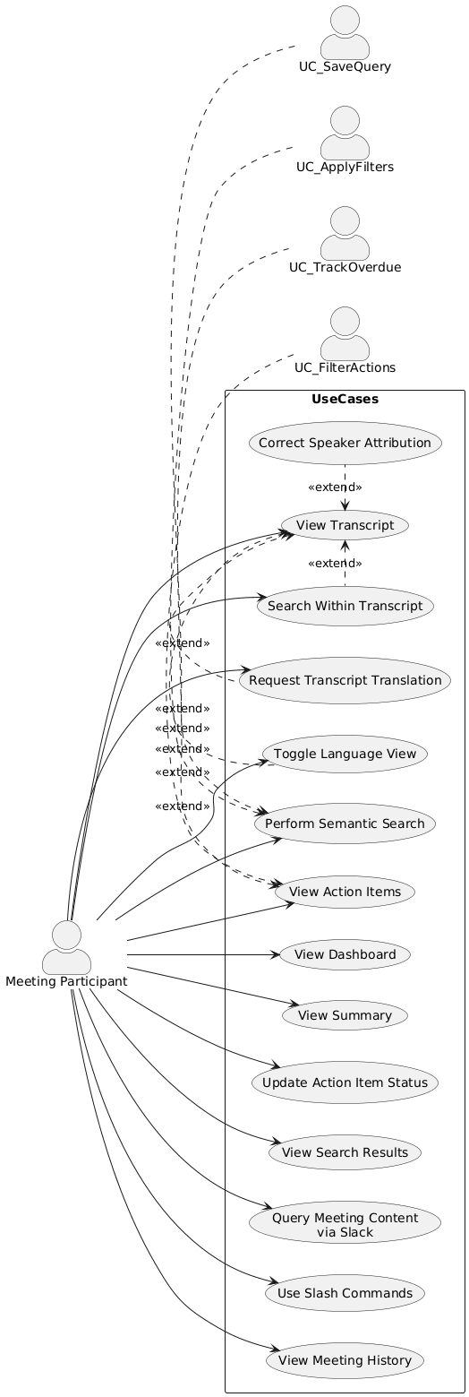
Figure 7. Meeting Participant

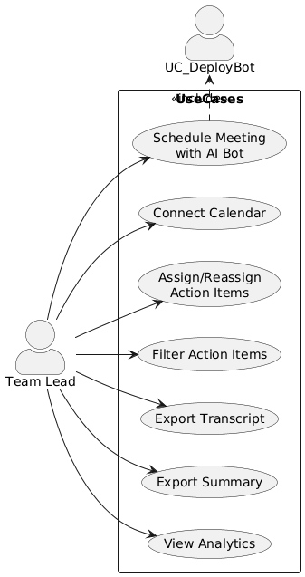
Figure 8. Team Lead
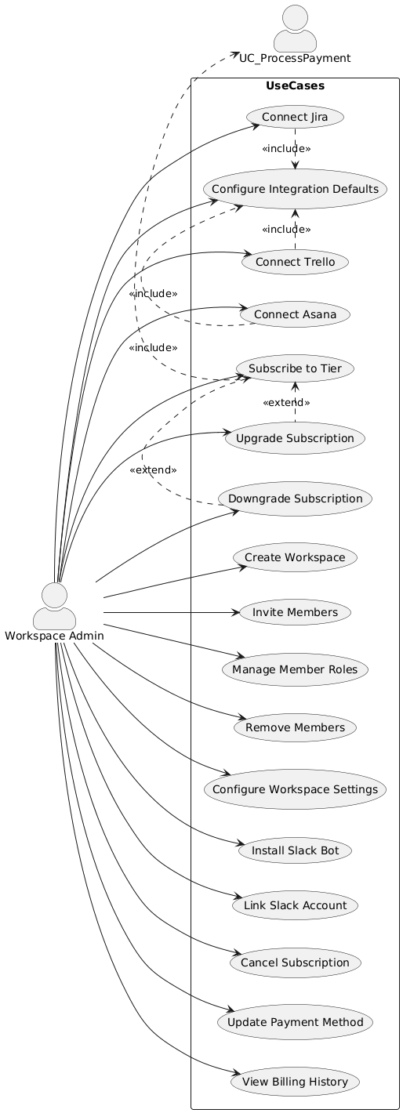
Figure 9. Workspace Admin
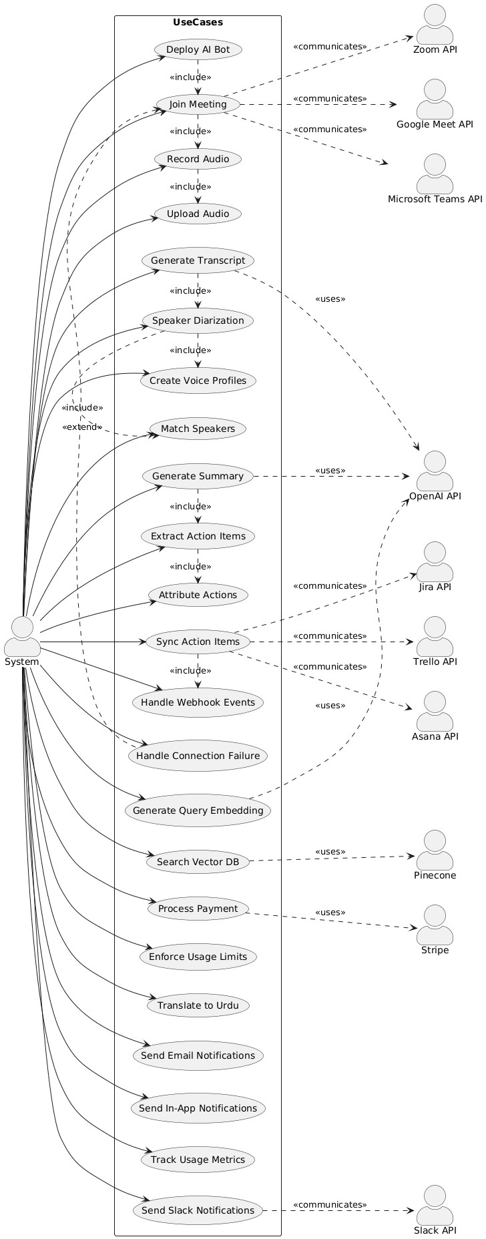
Figure 10. External Systems
4.7.1 Use Case Descriptions
Table 10. User Registration
UC-USER-01: User Registration and Account Creation
Use case Id: |  | UC-USER-01
Actors: New User: Individual creating an IntelliMeet Pro account
Feature: User Registration and Authentication
Pre-condition: |  | - User has valid email address  - User has internet access  - Registration page is accessible
Scenarios
Step# | Action |  |  | Software Reaction
1. | New user navigates to IntelliMeet Pro registration page |  |  | System displays registration form with fields for email, password, name
2. | User enters email address, creates password, provides full name |  |  | System validates input format in real-time (email format, password strength)
3. | User accepts Terms of Service and Privacy Policy |  |  | System enables registration button
4. | User clicks "Register" button |  |  | System validates all inputs, creates user account with hashed password, sends verification email
5. | User receives verification email and clicks verification link |  |  | System verifies email address, activates account, redirects to login page with success message
Alternate Scenarios:
1a: If entered email already exists in system, display error message "Email address already registered" and prompt login instead.
2a: If password does not meet complexity requirements (minimum 8 characters, uppercase, lowercase, number, special character), display validation error message below password field.
4a: If Terms of Service are not accepted, prevent registration submission and highlight checkbox.
5a: If verification link expires (after 24 hours), provide option to resend verification email.
Post Conditions
Step# | Description
 | User account created and activated
 | User can log in with credentials
 | User email address verified
Use Case Cross referenced |  |  | UC-USER-02 (User Login), UC-WS-01 (Create Workspace)
Table 11. User Login
UC-USER-02: User Login
Use case Id: |  | UC-USER-02
Actors: Registered User: Individual with existing IntelliMeet Pro account.
Feature: User Authentication
Pre-condition: |  | - User has registered account  - Email address is verified  - Login page is accessible
Scenarios
Step# | Action |  |  | Software Reaction
1. | User navigates to IntelliMeet Pro login page |  |  | System displays login form with email and password fields
2. | User enters email address and password |  |  | System accepts input.
3. | User clicks "Login" button |  |  | System validates credentials, creates session, generates JWT token, redirects to dashboard
4. | System displays user dashboard |  |  | Dashboard shows upcoming meetings, recent activity, pending action items
Alternate Scenarios:
3a: If credentials are invalid, display error message "Invalid email or password" without specifying which field is incorrect (security best practice). Do not lock account on first failure.
3b: If user enters invalid credentials 5 times within 15 minutes, temporarily lock account for 15 minutes and display "Account temporarily locked due to multiple failed login attempts. Please try again in 15 minutes or reset your password."
3c: If email address is not verified, display message "Please verify your email address" with option to resend verification email.

Post Conditions
Step# | Description
 | User successfully authenticated
 | Active session created with JWT token
 | User redirected to dashboard
Use Case Cross referenced |  |  | UC-USER-03 (Password Reset), UC-WS-02 (Select Workspace), UC-MEET-01 (Schedule Meeting).

Table 12. Create Workspace
UC-WS-01: Create Workspace
Use case Id: |  | UC-WS-01
Actors: Authenticated User: User creating new collaborative workspace
Feature: Workspace Management
Pre-condition: |  | - User is logged in  - User has not exceeded workspace creation limits for subscription tier
Scenarios
Step# | Action |  |  | Software Reaction
1. | User clicks "Create Workspace" button on dashboard |  |  | System displays workspace creation form
2. | User enters workspace name and optional description |  |  | System validates input (name 3-50 characters, description max 500 characters)
3. | User clicks "Create" button |  |  | System validates inputs, creates workspace record, assigns user as Admin, generates unique workspace ID
4. | System redirects user to new workspace dashboard |  |  | Displays empty workspace with prompts to invite members and schedule first meeting
Alternate Scenarios:
2a: If workspace name already exists for this user, suggest alternative name or allow duplicate with warning.
3a: If user has reached workspace creation limit for subscription tier (e.g., 5 workspaces for Professional), display upgrade prompt.

Post Conditions
Step# | Description
 | New workspace created
 | User assigned as workspace Admin
 | Weights are updated and applied to the AI model.
Use Case Cross referenced |  |  | UC-WS-02 (Invite Workspace Members), UC-MEET-01 (Schedule Meeting)

Table 13. Invite Workspace Members
UC-WS-02: Invite Workspace Members
Use case Id: |  | UC-WS-02
Actors: Workspace Admin or Team Lead: User with permissions to invite members
Feature: Workspace Member Management
Pre-condition: |  | - User is logged in  - User is Admin or Team Lead of workspace  - Workspace has not exceeded member limit for subscription tier
Scenarios
Step# | Action |  |  | Software Reaction
1. | User navigates to Workspace Settings > Members |  |  | System displays current member list and "Invite Member" button
2. | User clicks "Invite Member" button |  |  | System displays invitation form with email field and role selection (Team Lead or Member)
3. | User enters invitee email address and selects role |  |  | System validates email format
4. | User clicks "Send Invitation" button |  |  | System generates invitation token (valid 7 days), sends email with registration/join link, creates pending invitation record
5. | Invitee receives email and clicks join link |  |  | System validates token, allows invitee to register (if new) or join workspace (if existing user), assigns selected role
6. | System confirms successful addition |  |  | Both inviter and invitee receive confirmation notification
Alternate Scenarios:
3a: If entered email already exists as workspace member, display message "User is already a member of this workspace."
4a: If workspace member limit reached for subscription tier, display upgrade prompt instead of sending invitation.
5a: If invitation token has expired (after 7 days), display message "Invitation has expired. Please request a new invitation."

Post Conditions
Step# | Description
 | New member added to workspace
 | Member has assigned role (Team Lead or Member)
 | Member can access workspace meetings and content
Use Case Cross referenced |  |  | UC-WS-03 (Manage Member Roles), UC-MEET-01 (Schedule Meeting)
Table 14. Schedule Meetings
UC-MEET-01: Schedule Meeting with AI Bot
Use case Id: |  | Write use case reference number.
Actors: Team Lead or Admin: User scheduling meeting with AI bot attendance
Feature: Meeting Bot Deployment and Recording
Pre-condition: |  | - User is logged in  - User is Team Lead or Admin of workspace  - User has connected calendar or manual entry capability  - Meeting platform (Zoom/Google Meet/Teams) credentials configured
Scenarios
Step# | Action |  |  | Software Reaction
1. | User navigates to "Schedule Meeting" page |  |  | System displays meeting scheduling form
2. | User enters meeting title, date/time, selects platform (Zoom/Google Meet/Teams), enters meeting credentials (ID, passcode, or URL) |  |  | System validates input format
3. | User selects workspace for meeting association |  |  | System lists available workspaces where user has Team Lead or Admin role
4. | User enables "Deploy AI Bot" toggle |  |  | System confirms bot will automatically join meeting
5. | User clicks "Schedule Meeting" button |  |  | System validates all inputs, creates meeting record, schedules bot deployment task, displays confirmation with meeting details
6. | Five minutes before meeting start time, system initiates bot deployment |  |  | Bot authenticates with platform, joins meeting, begins audio recording
7. | During meeting, bot maintains stable connection |  |  | Bot status displayed as "Recording" on user dashboard
8. | Meeting ends or bot is manually removed |  |  | Bot gracefully exits, uploads audio to Azure Blob Storage, triggers transcription pipeline, updates meeting status to "Processing"
Alternate Scenarios:
2a: If meeting credentials are invalid or incomplete, display validation error specifying missing information.
6a: If bot deployment fails due to authentication error, log error details, notify user via email and in-app notification, display troubleshooting guidance.
6b: If bot loses network connection during meeting, implement auto-reconnect with exponential backoff (maximum 5 attempts). If reconnection fails, log interruption and capture partial audio.
7a: If user manually removes bot before meeting end, confirm action and proceed with audio upload and processing of captured content.

Post Conditions
Step# | Description
 | Meeting scheduled with bot deployment
 | Bot successfully joins and records meeting audio
 | Audio uploaded to storage
 | Transcription pipeline initiated
Use Case Cross referenced |  |  | .  UC-TRANS-01 (Generate Transcript), UC-SUM-01 (Generate Meeting Summary)

Table 15. Generate Meeting Transcript
UC-TRANS-01: Generate Meeting Transcript
Use case Id: |  | UC-TRANS-01
Actors: System (Automated Process): Transcription pipeline triggered by meeting completion
Feature: Transcription and Speaker Diarization
Pre-condition: |  | - Meeting audio successfully uploaded to Azure Blob Storage  - Meeting status is "Processing"  - OpenAI Whisper API is accessible
Scenarios
Step# | Action |  |  | Software Reaction
1. | Audio upload completes |  |  | System detects new audio file, adds transcription task to processing queue
2. | Transcription worker retrieves audio file |  |  | Worker downloads audio from Azure Blob Storage
3. | Worker submits audio to OpenAI Whisper API |  |  | API processes audio, returns timestamped transcript segments with preliminary speaker labels
4. | Worker receives transcript response |  |  | Worker performs speaker diarization to identify distinct speakers
5. | Diarization algorithm matches speakers with existing voice profiles |  |  | System assigns speaker names to segments based on voice profile similarity (85%+ confidence threshold) or creates new profiles
6. | Worker saves transcript to database |  |  | Transcript stored with speaker attributions, timestamps, confidence scores
7. | System updates meeting status to "Transcription Complete" |  |  | Dashboard displays transcript availability, sends notification to workspace members
8. | User views meeting details page |  |  | Transcript displayed with speaker labels, timestamps, synchronized audio playback
Alternate Scenarios:
3a: If Whisper API request fails due to transient error, implement exponential backoff retry (maximum 3 attempts).
4a: If audio quality is poor (excessive noise, very low volume), log quality warnings, attempt best-effort transcription, mark low-confidence segments, notify user.
5a: If speaker cannot be matched to existing profile (confidence <85%), assign temporary label (e.g., "Speaker 3"), prompt meeting organizer to identify speaker.
7a: If transcription processing exceeds 10 minutes for standard meeting length (60 minutes), send interim status update to user.

Post Conditions
Step# | Description
 | Complete transcript generated with speaker attribution
 | Transcript stored in database
 | Meeting status updated to "Transcription Complete"
 | Users notified and can access transcript
Use Case Cross referenced |  |  | UC-SUM-01 (Generate Meeting Summary), UC-SEARCH-01 (Semantic Search), UC-TRANS-02 (Correct Speaker Attribution)

Table 16. Generate Meeting Summary
UC-SUM-01: Generate AI-Powered Meeting Summary
Use case Id: |  | UC-SUM-01
Actor: |  | System (Automated Process): Summarization pipeline triggered by transcription completion
Feature: AI-Powered Summarization and Insights
Pre-condition: |  | - Meeting transcript is complete  - Transcript stored in database with speaker attribution  - OpenAI GPT-4 API is accessible
Scenarios
Step# | Action |  |  | Software Reaction
1. | Transcription completes successfully |  |  | System triggers summarization task
2. | Summarization worker retrieves complete transcript |  |  | Worker formats transcript for GPT-4 processing
3. | Worker submits transcript to GPT-4 API with structured prompting template |  |  | Template instructs model to generate: Executive Overview (100-200 words), Key Discussion Points (3-7 items), Decisions Made (numbered list), Action Items (with assignees), Next Steps
4. | GPT-4 API returns structured summary response |  |  | Worker parses response into structured components
5. | Worker extracts action items with participant attribution |  |  | System creates action item records linked to meeting, assigns to identified participants, sets preliminary priority based on context
6. | Worker saves summary and action items to database |  |  | Summary stored with sections, action items stored as separate records
7. | System updates meeting status to "Summary Ready" |  |  | Dashboard displays summary availability, sends notification email to participants with summary preview
8. | User views meeting details page |  |  | Summary displayed with expandable sections, action items shown separately with status indicators
Alternate Scenarios:
2a: If transcript exceeds GPT-4 context window (8,000 tokens), segment transcript into sections, generate partial summaries, synthesize into unified final summary.
4a: If GPT-4 API request fails, implement exponential backoff retry (maximum 3 attempts). If all attempts fail, log error, notify user, offer manual summary request option.
5a: If action item assignee cannot be confidently determined from context, flag as "Unassigned," notify meeting organizer for manual assignment.
7a: If summarization processing time exceeds 7 minutes, send interim progress notification to user.

Post Conditions
Step# | Description
 | Comprehensive meeting summary generated
 | Action items extracted and assigned
 | Summary and action items stored in database
 | Participants notified via email and in-app
Use Case Cross referenced |  |  | UC-ACTION-01 (View Action Items), UC-INTEG-01 (Sync Action Items with Jira), UC-SUM-02 (Export Meeting Summary)

Table 17. Semantic Search
UC-SEARCH-01: Perform Semantic Search Across Meetings
Use case Id: |  | UC-SEARCH-01
Actors: Workspace Member: User searching for information from past meetings

Feature: Semantic Search and Knowledge Retrieval
Pre-condition: |  | - User is logged in  - User is member of workspace with meeting content  - Transcript embeddings indexed in Pinecone
Scenarios
Step# | Action |  |  | Software Reaction
1. | User enters natural language query in global search bar (e.g., "What did we decide about the marketing budget?") |  |  | System captures query text
2. | User presses Enter or clicks Search button |  |  | System generates query embedding using OpenAI text-embedding-ada-002 model
3. | System performs similarity search in Pinecone vector database |  |  | Pinecone returns top 10 most relevant transcript segments with similarity scores
4. | System applies access control filters |  |  | Only results from meetings in user's authorized workspaces are included
5. | System displays search results |  |  | Results shown with relevance score, contextual excerpt (100-200 characters), speaker name, meeting title/date, direct link to full transcript
6. | User clicks on search result |  |  | System navigates to meeting detail page, scrolls to and highlights matching transcript segment
Alternate Scenarios:
3a: If no results exceed relevance threshold (similarity score <0.7), display "No relevant results found" with suggestions to broaden query or check spelling.
3b: If search query processing time exceeds 30 seconds, display progress indicator and inform user "Searching across meetings..."
4a: If user applies additional filters (date range, specific workspace, speaker), system refines search to match criteria and re-ranks results.
5a: If user saves query to favorites, store in user profile for quick re-execution from query history panel.

Post Conditions
Step# | Description
 | Relevant meeting content retrieved
 | Results displayed with context
 | User can access full source transcript
Use Case Cross referenced |  |  | UC-TRANS-01 (View Transcript), UC-SEARCH-02 (Apply Advanced Search Filters)

Table 18. Synchronize Action Items
UC-INTEG-01: Synchronize Action Items with Jira
Use case Id: |  | UC-INTEG-01
Actors: |  | System (Automated Process): Integration worker synchronizing tasks  Workspace Admin: User configuring integration
Feature: Project Management Integration
Pre-condition: |  | - Workspace Admin has connected Jira account via OAuth  - Default Jira project configured for workspace  - Action items extracted from meeting summary
Scenarios
Step# | Action |  |  | Software Reaction
1. | Admin navigates to Workspace Settings > Integrations |  |  | System displays available integrations (Jira, Trello, Asana)
2. | Admin clicks "Connect Jira" button |  |  | System initiates OAuth 2.0 flow, redirects to Jira authorization page
3. | Admin authorizes IntelliMeet Pro access to Jira |  |  | System receives OAuth tokens, stores securely in Azure Key Vault, retrieves available Jira projects
4. | Admin selects default Jira project and issue type |  |  | System saves configuration to workspace settings
5. | Action items extracted from new meeting |  |  | System automatically creates corresponding Jira issues
6. | For each action item, system creates Jira issue |  |  | Maps IntelliMeet Pro fields to Jira: description→summary, full context→description, assigned user→assignee, priority→priority, source meeting link→custom field
7. | Jira API returns created issue IDs |  |  | System stores external issue IDs in action item records, displays sync confirmation to user
8. | User marks action item complete in IntelliMeet Pro |  |  | System updates linked Jira issue status to "Done" via API
9. | External user updates Jira issue status |  |  | Jira webhook notification triggers sync, system updates corresponding action item status in database, sends notification to meeting organizer
Alternate Scenarios:
3a: If OAuth authorization fails or is denied, display error message, allow retry.
5a: If action item lacks clear assignee, flag as "Unassigned" and do not sync to Jira until assigned.
6a: If Jira API rate limit is reached, queue action item for retry with exponential backoff.
6b: If task creation fails due to invalid project/field configuration, log error, notify workspace admin, provide configuration troubleshooting link.
9a: If webhook signature validation fails, reject event, log security warning.

Post Conditions
Step# | Description
 | Jira account connected to workspace
 | Action items automatically synchronized as Jira issues
 | Bidirectional status updates maintained
 | Meeting discussions linked to project management workflow
Use Case Cross referenced |  |  | UC-ACTION-01 (View Action Items), UC-INTEG-02 (Configure Trello Integration), UC-INTEG-03 (Configure Asana Integration).

UC-SLACK-01: Query Meeting Content via Slack Bot
Use case Id: |  | UC-SLACK-01
Actors: Slack Workspace Member: User interacting with IntelliMeet Pro bot in Slack
Feature: Slack Bot Conversational Assistant
Pre-condition: |  | - IntelliMeet Pro Slack bot installed in workspace  - User's Slack account linked to IntelliMeet Pro account  - Bot has necessary Slack permissions
Scenarios
Step# | Action |  |  | Software Reaction
1. | User opens direct message with @IntelliMeetPro bot in Slack |  |  | Bot displays welcome message with available commands
2. | User types natural language query: "What were the action items from yesterday's standup?" |  |  | Bot receives message via Slack Events API
3. | Bot parses query to determine intent (retrieve action items) and parameters (date: yesterday, meeting type: standup) |  |  | Bot queries IntelliMeet Pro backend API for matching action items
4. | Backend returns action items matching criteria |  |  | Bot formats response using Slack Block Kit with bullet points, assignee names, and "View Full Transcript" button
5. | Bot sends formatted response in thread |  |  | User sees action items directly in Slack
6. | User clicks "View Full Transcript" button |  |  | Bot sends ephemeral message (visible only to user) with secure link to meeting details page in IntelliMeet Pro web app
Alternate Scenarios:
3a: If query is ambiguous (e.g., multiple meetings match "yesterday's standup"), bot requests clarification: "I found 2 standup meetings yesterday. Which one? [Meeting A at 9 AM] [Meeting B at 3 PM]"
4a: If no matching action items found, bot responds: "I couldn't find any action items from yesterday's standup. Would you like to search all meetings from yesterday?"
5a: If user uses slash command /intellimeet search budget discussion, bot performs semantic search and returns top 3 results in ephemeral message.

Post Conditions
Step# | Description
 | User receives requested meeting information in Slack
 | User can access full content via provided links
 | Interaction logged for query accuracy tracking
Use Case Cross referenced |  |  | UC-SEARCH-01 (Semantic Search), UC-ACTION-01 (View Action Items), UC-SLACK-02 (Configure Slack Notifications)

Table 19. Subscribe
UC-SUB-01: Subscribe to Professional Tier
Use case Id: |  | UC-SUB-01
Actors: User: Individual selecting paid subscription tier
Feature: Subscription and Payment Processing
Pre-condition: |  | - User is logged in  - User currently on Basic (free) tier  - Stripe payment processing is operational
Scenarios
Step# | Action |  |  | Software Reaction
1. | User navigates to Subscription page |  |  | System displays subscription tier comparison table (Basic, Professional, ) with features and pricing
2. | User clicks "Upgrade to Professional" button |  |  | System displays Stripe Checkout interface embedded in page
3. | User enters payment information (card number, expiration, CVC) via Stripe Elements |  |  | Stripe Elements securely tokenizes payment method (card details never touch IntelliMeet Pro servers)
4. | User clicks "Subscribe" button |  |  | System creates Stripe Customer object, creates Subscription object with monthly billing, processes initial payment
5. | Stripe processes payment successfully |  |  | Stripe returns subscription confirmation, sends webhook event to IntelliMeet Pro
6. | System receives webhook notification |  |  | System validates webhook signature, updates user subscription status to "Professional," applies new usage limits, sends confirmation email with receipt
7. | User redirected to dashboard |  |  | Dashboard displays "Professional" tier badge, shows updated usage limits (increased meeting minutes, workspace members, features)
Alternate Scenarios:
4a: If payment fails due to declined card, display error message from Stripe with reason (insufficient funds, invalid card, etc.), allow user to update payment method and retry.
5a: If webhook delivery fails (network issue), system polls Stripe API to check subscription status until confirmed.
6a: If webhook signature validation fails, reject event, log security alert, prevent unauthorized subscription changes.
Post Conditions
Step# | Description
 | User subscribed to Professional tier
 | Payment processed successfully
 | Enhanced features and limits activated
 | Recurring billing established
Use Case Cross referenced |  |  | UC-SUB-02 (Manage Subscription), UC-SUB-03 (View Billing History), UC-USER-04 (Update Payment Method)

Sequence Diagram

User Registration + User Login
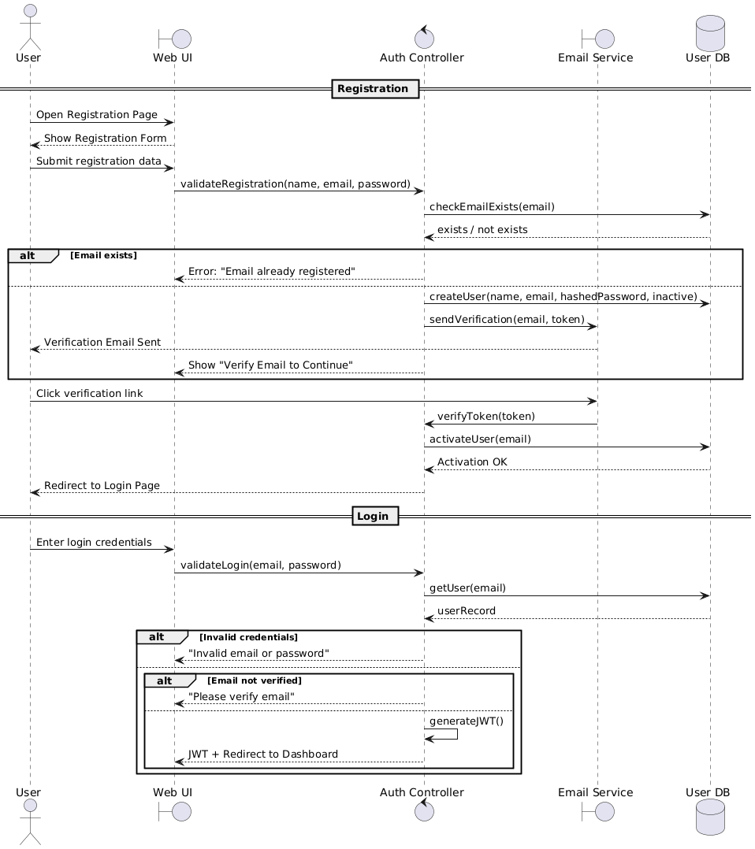
Figure 11. User Registration & Login
The user begins by opening the registration page, submitting their details, and the system validates the email, creates an inactive user, and sends a verification email. After clicking the verification link, the user’s account is activated, and they are redirected to the login page. During login, the system verifies credentials and checks email verification status. If all validations pass, the system generates a JWT token and redirects the user to the dashboard.

Create Workspace & Invite Members
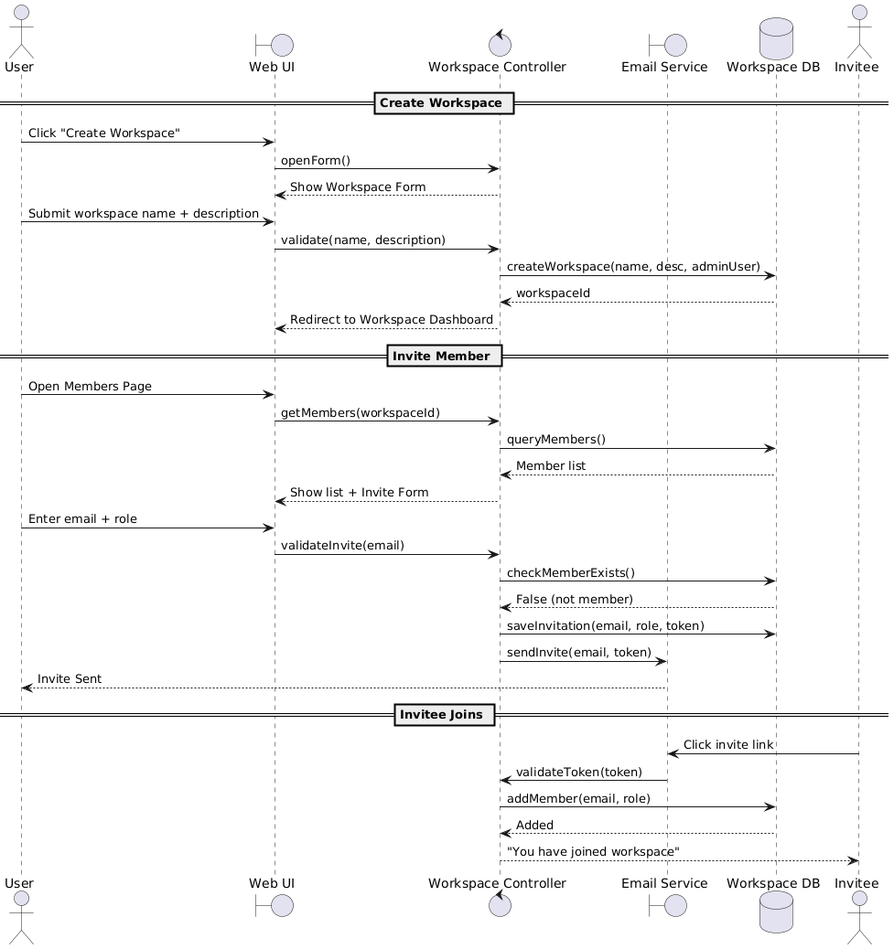
Figure 12. Create workspace & Invite Members
The user opens the workspace creation form, provides the workspace details, and the system stores the new workspace and assigns the user as the admin. When inviting members, the user opens the Members page, reviews existing members, and submits an invite form. The system validates the invitee email, stores the invitation, sends an invite email, and once the invitee clicks the link, they are added to the workspace with the assigned role

Schedule Meeting with AI Bot
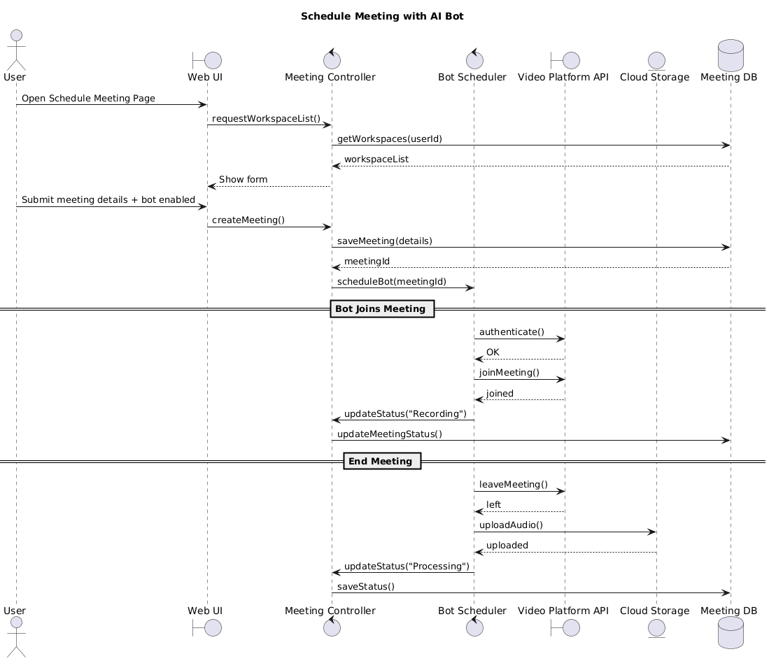
Figure 13. Schedule Meeting
The user accesses the meeting scheduling page, selects a workspace, enters meeting details, and chooses to deploy the AI bot. The system saves the meeting and schedules the bot. Before the meeting starts, the bot authenticates with the video platform, joins the meeting, records audio, and updates the meeting status. When the meeting ends, the bot leaves, uploads the audio to cloud storage, and marks the meeting as ready for processing.

Transcript + Summary
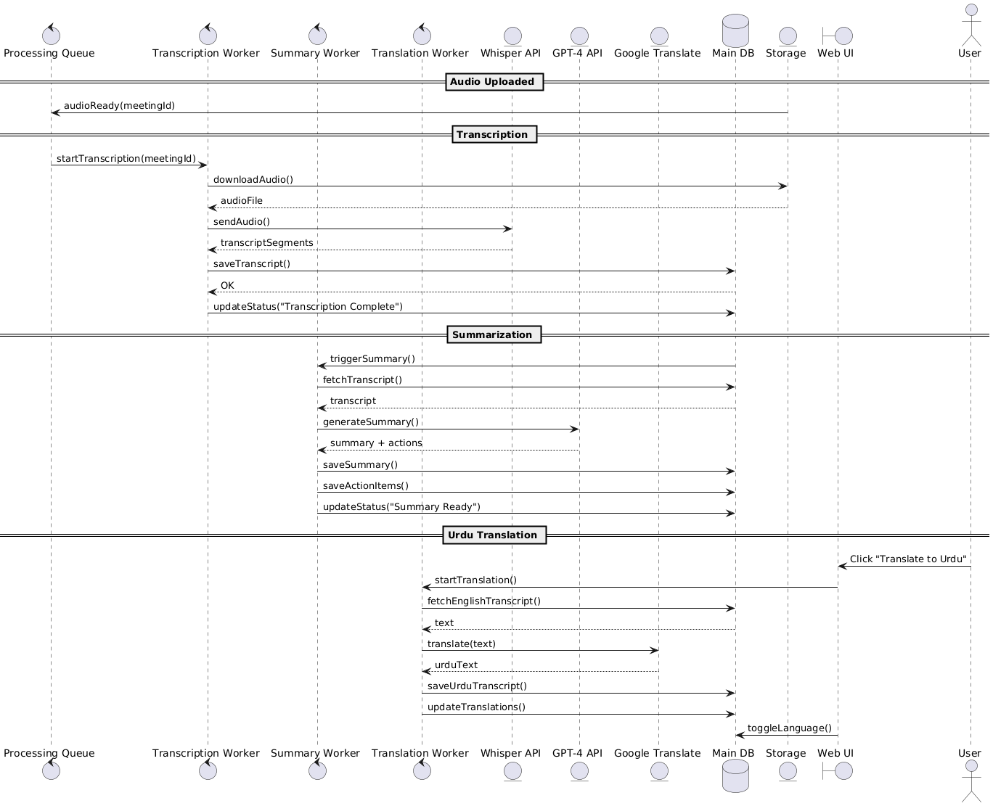
Figure 14. Transcript + Summary
Once the meeting audio is uploaded, the system queues a transcription task, downloads the audio, and processes it through Whisper to generate transcript segments. The system saves the transcript and triggers the summarization worker, which retrieves the transcript and uses GPT-4 to produce a structured summary and action items, storing both in the database. When the user requests translation, the translation worker fetches the transcript, sends text to Google Translate, stores the Urdu version, and updates available language options for viewing.

Semantic Search
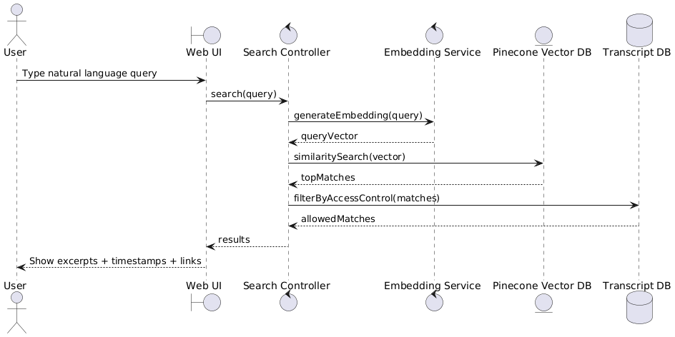
Figure 15. Semantic Search
The user enters a natural-language query in the UI, which is forwarded to the search controller. The system generates an embedding vector for the query, searches Pinecone for semantically similar transcript segments, and applies access-control filtering. The UI then displays the most relevant excerpts, including speaker information and direct links to the corresponding transcript sections.

Action items sync with PM tool (Jira Sync)
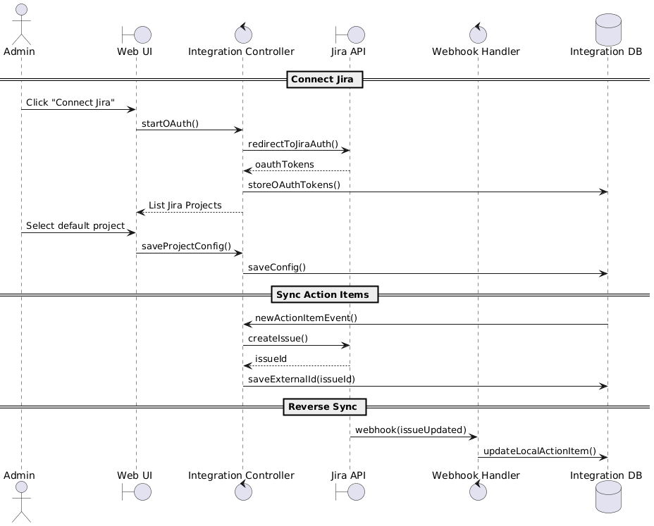
Figure 16. Action Items Sync
The admin initiates Jira integration by starting OAuth, authorizing access, and selecting a default Jira project. The system stores OAuth tokens and configuration. When new action items are generated, the integration controller automatically creates corresponding Jira issues, stores their external IDs, and synchronizes updates. Incoming Jira webhook events update the corresponding local action item statuses in IntelliMeet Pro.

Query Meeting Content via Slack Bot
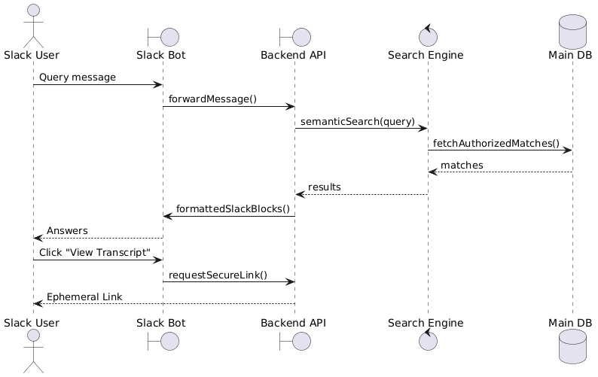
Figure 17. Query Meeting Content
The user sends a query to the Slack bot, which forwards the message to the backend API. The backend performs semantic search on meeting content, retrieves authorized results, and returns formatted Slack message blocks. The user may click “View Transcript,” prompting the bot to request a secure link from the backend and send it as an ephemeral message accessible only to the requesting user.

State Diagram

Authentication & Account Lifecycle

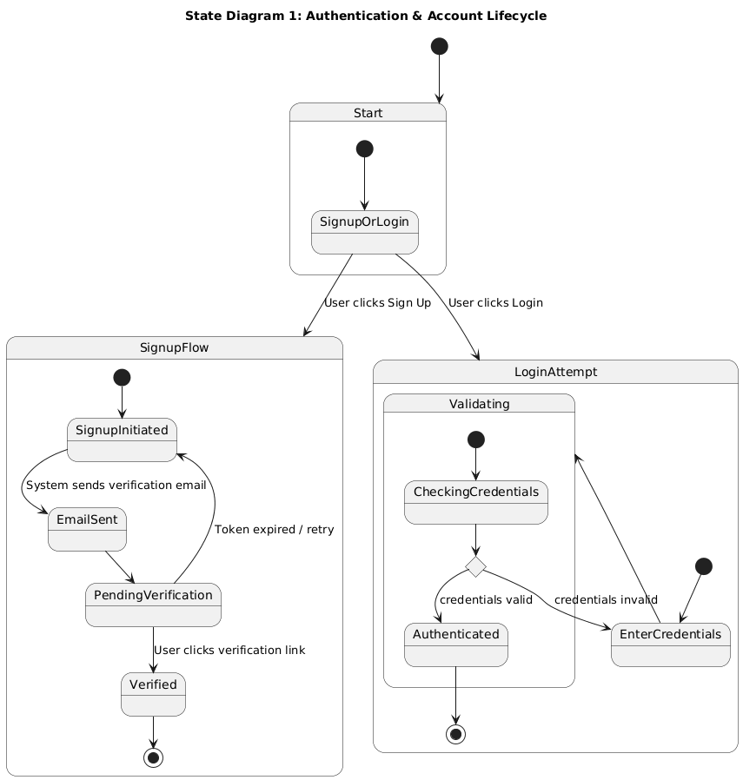
Figure 18. Authentication & Account Lifestyle
The overall login and signup process begins with users choosing whether to create an account or log in. New users complete the signup flow by receiving and confirming a verification email before accessing the system. Returning users enter their credentials, which are validated before granting access.

Meeting Processing Lifecycle
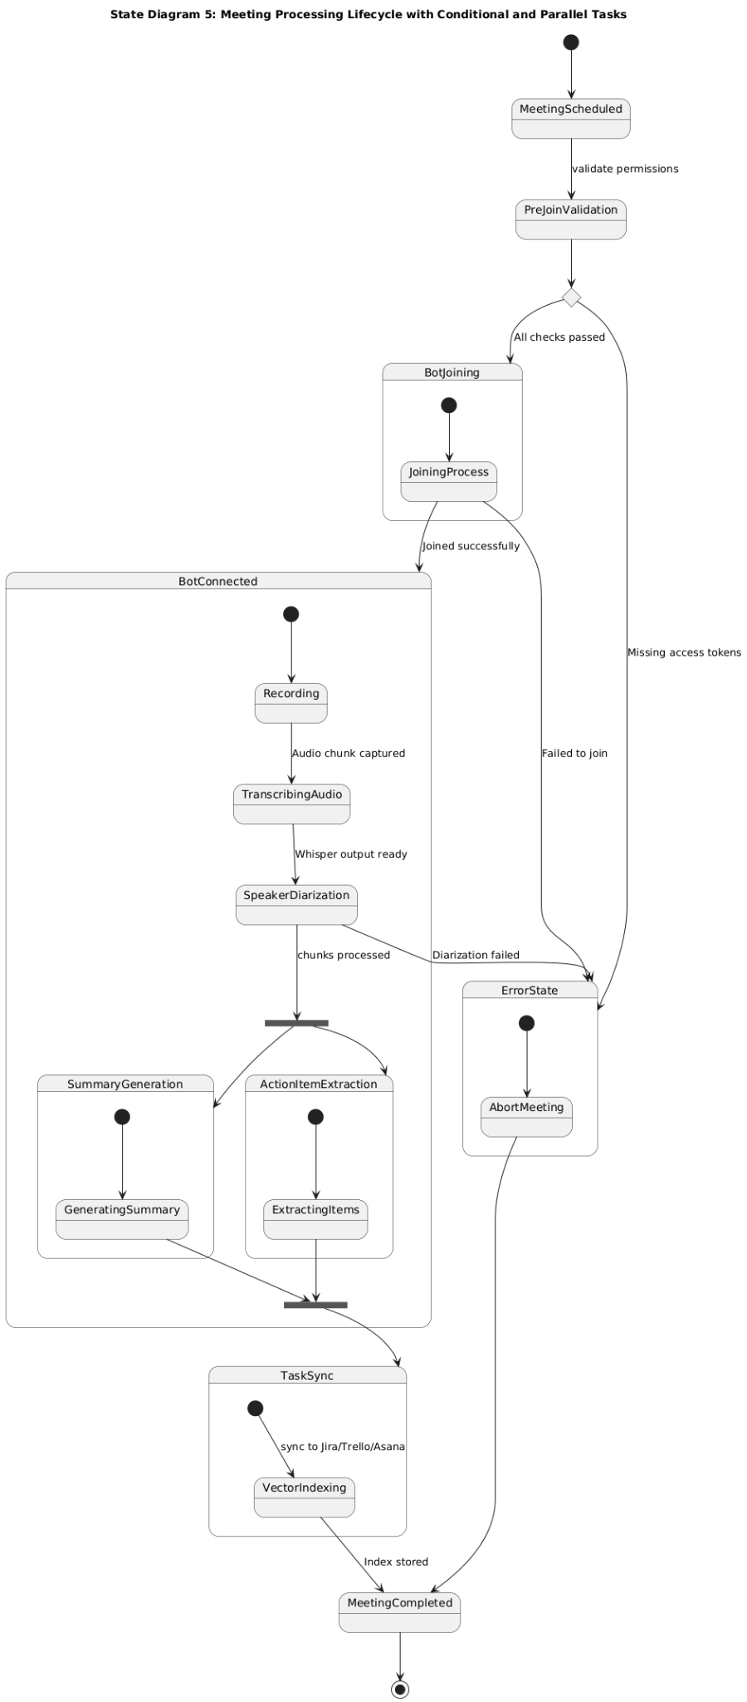
Figure 19. Meeting Processing
This shows the automated meeting life cycle. If a meeting is scheduled, and prejoin validation clears, the bot joins the meeting, otherwise moves to error state. During the meeting, the bot records audio, transcribes and performs speaker diarization. The audio is processed and forked into parallel tasks: summary generation and action item extraction. The action items are synchronized with PM tools through vector indexing. Any failures lead to an error state, where the meeting is aborted. Upon successful completion of all steps or error handling, the meeting process is marked as completed.

RAG Semantic Search Flow
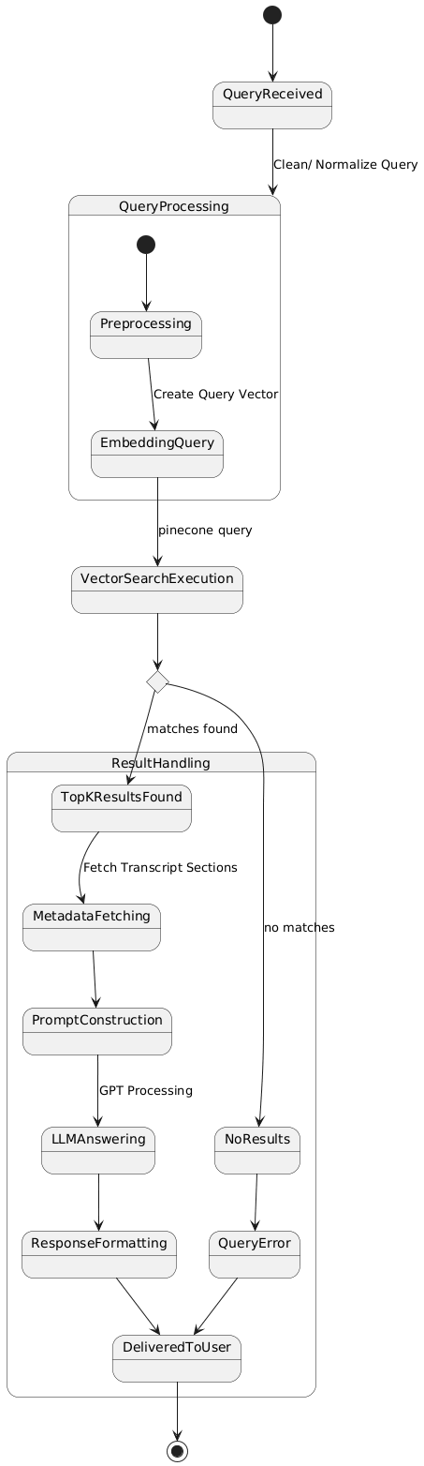
Figure 20. RAG Semantic Search Flow
When a query is received, it is cleaned/normalized, then processed by creating a query vector. This vector triggers a vector search (e.g., Pinecone) to find relevant results. If matches are found, the top results are used to fetch metadata/transcript sections, construct a prompt, and format the response before delivering it to the user. If no results are found, the system triggers a query error, which is also delivered to the user.

Workspace & RBAC Flow
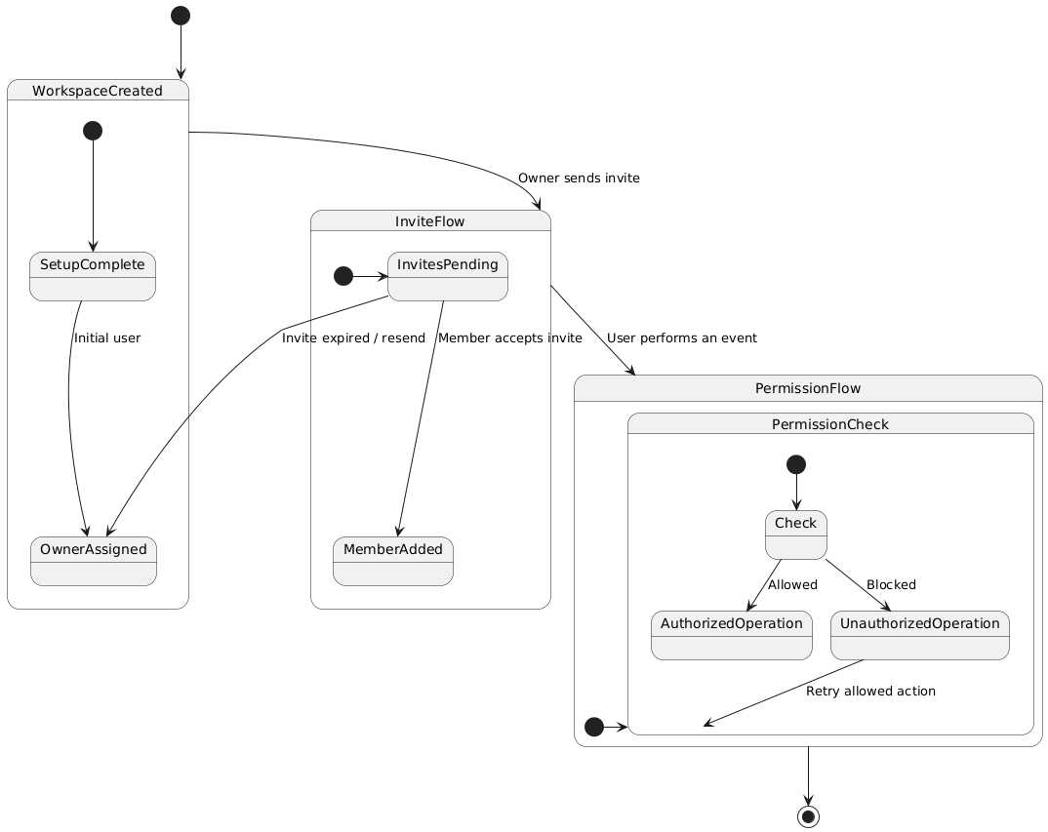
Figure 21. Workspace & RBAC Flow
After a workspace is created, the initial user becomes the owner, who can then send invites to other members. Invitees move through the invite flow, where they either accept and become members or require a resend if the invite expires. When any user performs an action, the system enters the permission flow, where it checks whether the operation is authorized. Allowed actions proceed normally, while blocked actions return the user to retry with a permitted operation, and the process ends once permission handling is complete.

Payment & Subscription Lifecycle

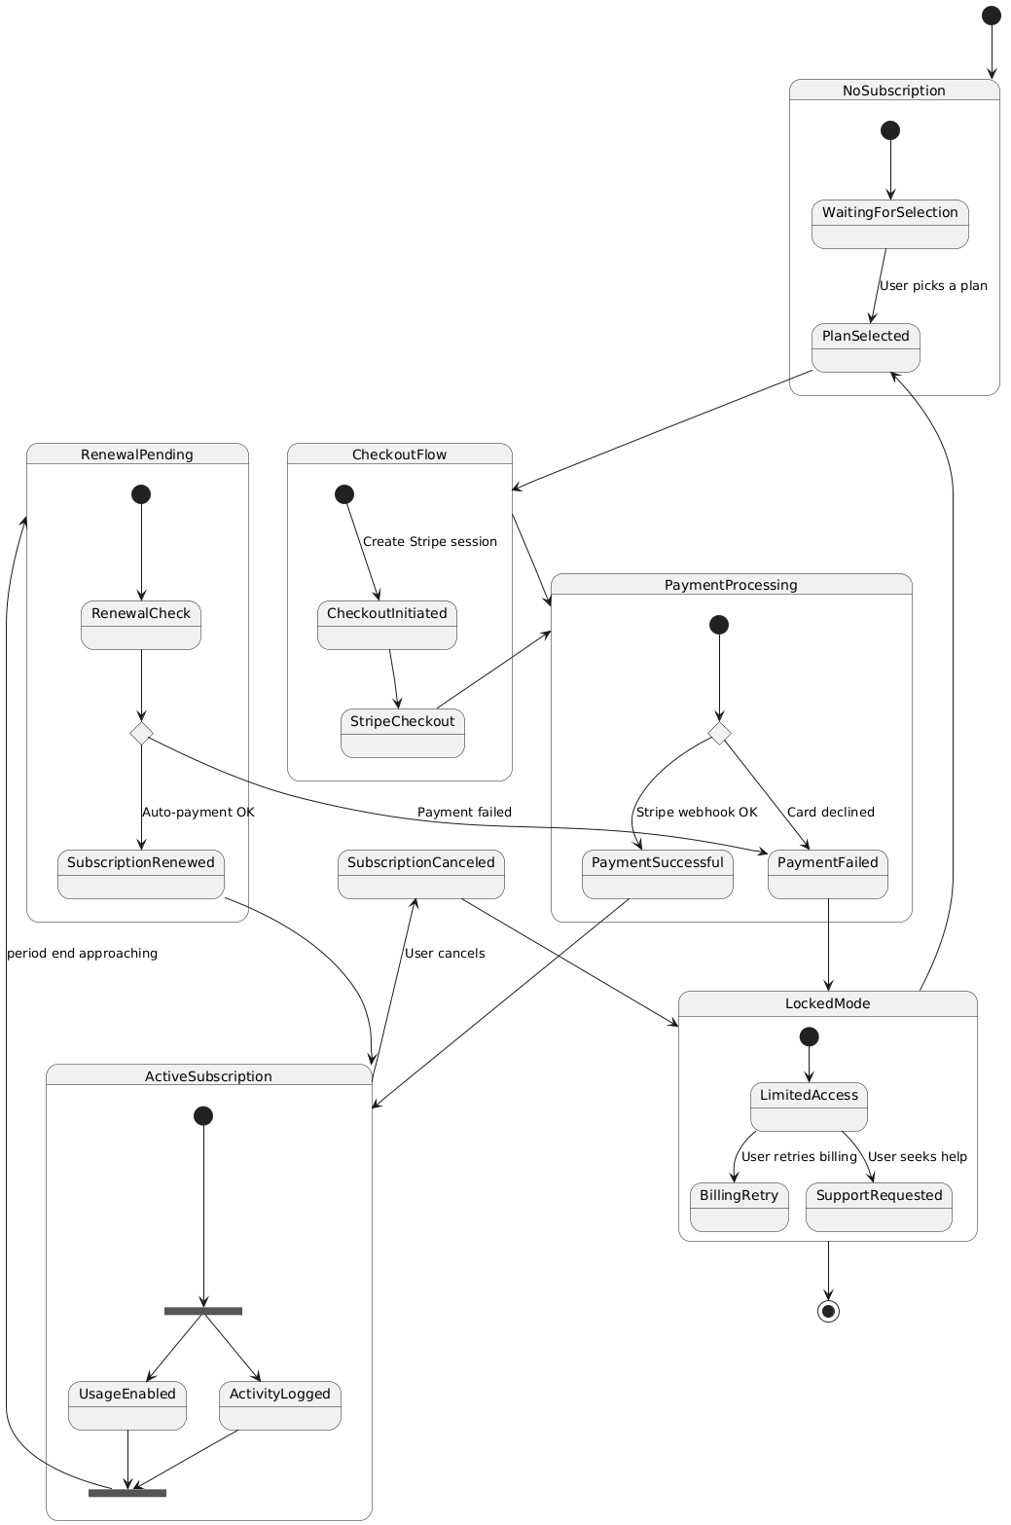
Figure 22. Payment & Subscription
This is a full subscription lifecycle starting from a user with no subscription, who selects a plan and enters a checkout flow that creates a Stripe session and processes payment. Based on Stripe’s webhook, the payment either succeeds which will activate the subscription or fails, which will send the user into a locked mode with limited access until billing is retried or support is requested. When active, the subscription runs parallel processes for enabling usage and logging activity, then moves toward renewal as the billing period ends. During renewal, auto-payment either successfully renews the subscription or fails, again transitioning the user to locked mode. Users may also cancel manually, which moves the system to a canceled state with restricted access, from which they may restart the subscription flow by selecting a plan again.

Data Flow Level 1 Diagram

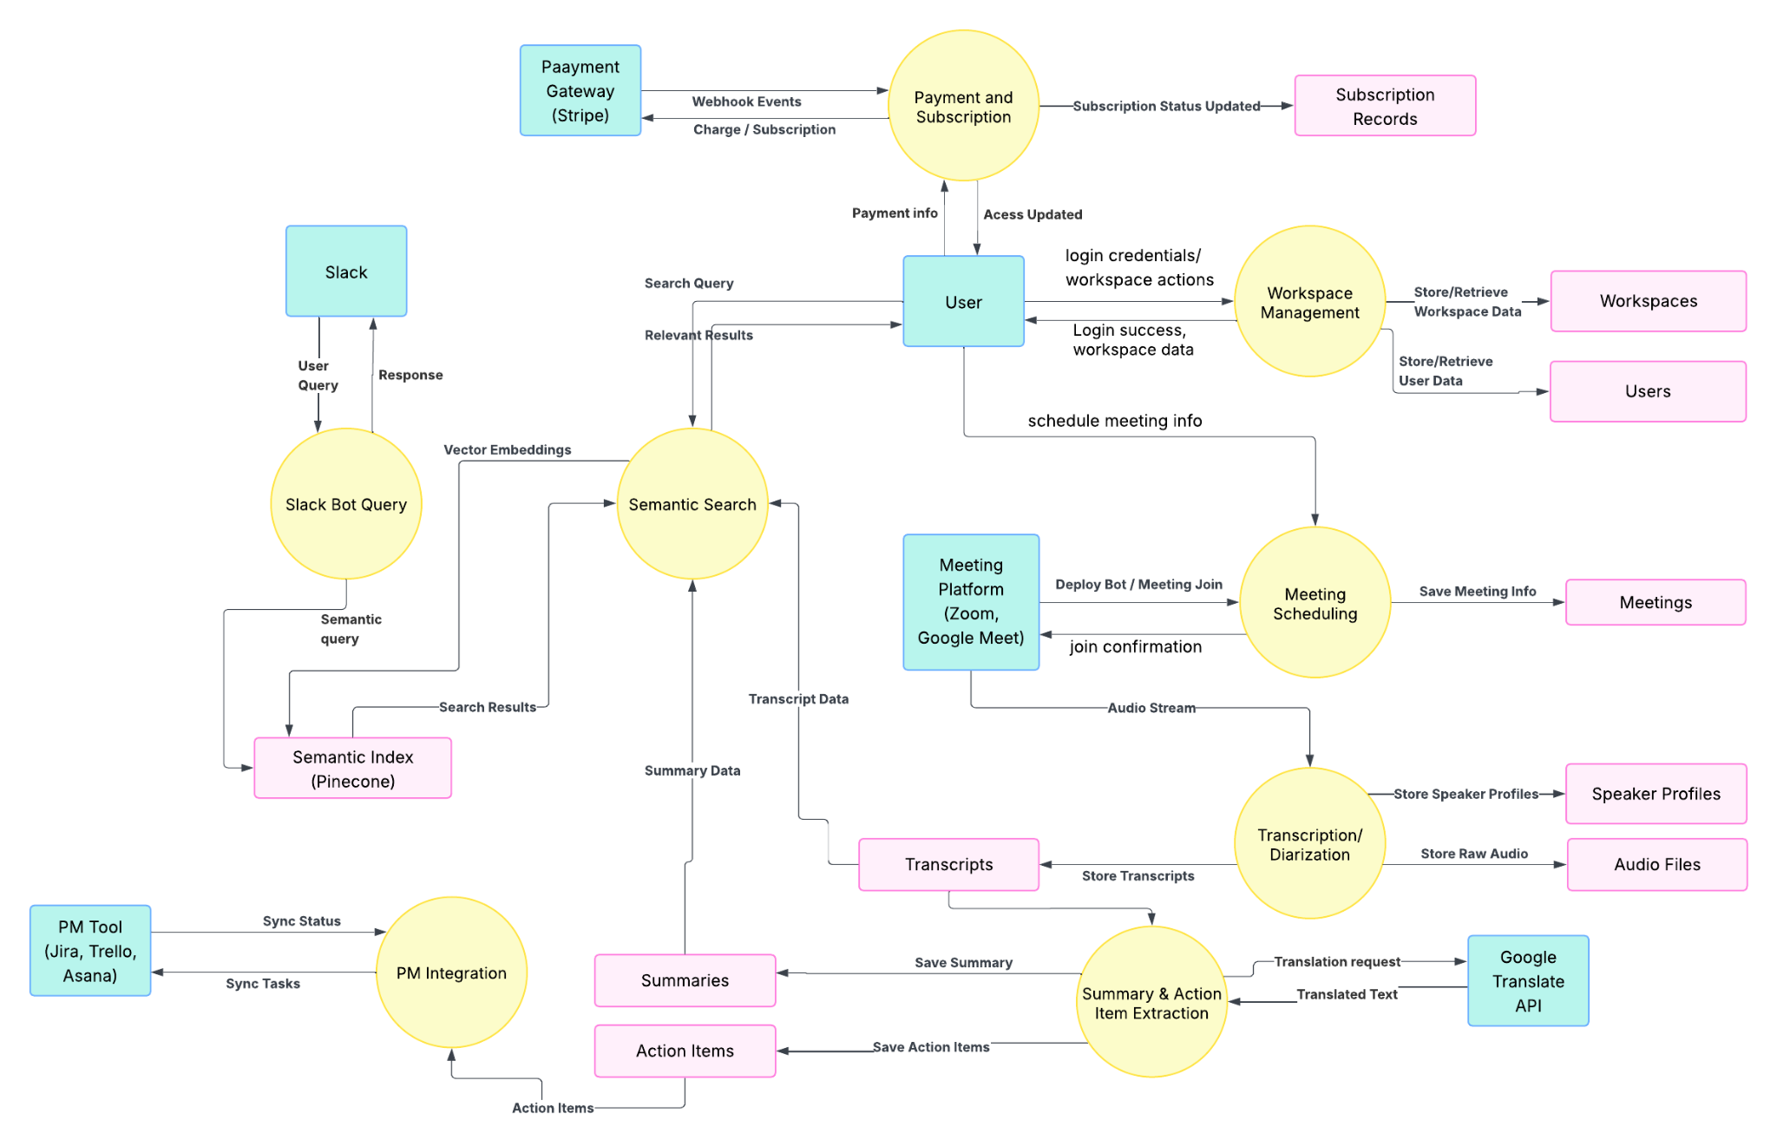
Figure 23. DFD Diagram

This Level-1 DFD shows how IntelliMeet Pro processes meeting data end-to-end: the user authenticates, manages their workspace, and schedules meetings, which triggers the bot to join external meeting platforms. Audio from the meeting is sent to the transcription/diarization module, producing transcripts, speaker profiles, and audio files that feed into the summary and action item extraction process. Summaries and action items are stored and used by the semantic search engine, which also powers Slack bot queries. Action items are synced with external project management tools, while the payment system manages subscriptions through Stripe and updates access permissions.

5. Implementation
The project will proceed through the following phases:
Phase 1: Requirements Analysis (Sept – Oct 2025)
- Gather and document requirements through stakeholder meetings.
- Develop the Software Requirements Specification (SRS).
- Conduct literature review to validate feasibility.
Phase 2: System Design (Oct 2025)
- Design system architecture, data flow, and interaction layers.
- Create database schema and ERD diagrams.
- Prepare wireframes and UI prototypes.
- Document the Software Design Specification (SDS).
Phase 3: Implementation (Nov 2025 – Mar 2026)
- Develop modules in a sequential manner:
  - Authentication & Scheduling
  - AI Transcription & Diarization
  - Meeting Summarization & Action Items
  - Semantic Search & Workflow Integrations
  - Slack Bot, UI/UX, Bilingual Support, Payment & Notifications
- Code development aligned with the finalized SDS.
Phase 4: Integration & Testing (Jan – Apr 2026)
- Conduct module-level testing, followed by system-wide integration testing.
- Debug and refine each component.
- Perform Quality Assurance (QA), scalability testing, and performance evaluation.
Phase 5: Deployment & Documentation (Apr – May 2026)
- Deploy IntelliMeet Pro to cloud infrastructure.
- Deliver user manuals, technical reports, and training materials.
- Conduct stakeholder training and demonstration sessions.
Phase 6: Final Evaluation & Presentation (May 2026)
- Prepare an open house demo.
- Conduct final project defense, viva, and evaluation.
- Submit retirement planning report and final deliverables.

6. Testing and Evaluation
The IntelliMeet Pro system has been evaluated through functional, performance, integration, and usability testing to ensure reliability, accuracy, and scalability. Each module has been tested independently before conducting complete system integration testing.

1. Functional Testing
Functional testing has been performed to verify that all core features operate according to the system requirements. This includes:
- User authentication and role-based access control
- Automatic meeting bot deployment and calendar synchronization
- Audio recording and transcript generation
- Speaker diarization and speaker attribution
- AI-generated summaries and action item extraction
- Semantic search across meeting histories
- Slack bot query handling
- Jira, Trello, and Asana task synchronization
- Subscription and payment workflow validation
The expected outputs have been compared with actual system behavior to ensure correctness.

2. Transcription Accuracy Evaluation
The speech-to-text module has been evaluated using Word Error Rate (WER) and transcription accuracy metrics. Meeting recordings containing multiple speakers and different accents have been tested to measure robustness.
Result:
- The system has achieved approximately 90% transcription accuracy for English meetings.

3. Speaker Diarization Testing
Speaker identification performance has been evaluated by comparing predicted speaker labels with manually annotated meeting recordings.
Metrics used:
- Speaker attribution accuracy
- Diarization Error Rate (DER)
The system has successfully identified and differentiated speakers in multi-speaker meeting environments.

4. Summarization and Action Item Evaluation
Meeting summaries and extracted tasks have been evaluated through manual comparison with human-written summaries.
Evaluation criteria included:
- Relevance of generated summaries
- Accuracy of extracted decisions and action items
- Correct participant attribution
- Context preservation
User feedback has indicated that the generated summaries are concise, readable, and useful for post-meeting review.

5. Performance and Scalability Testing
The platform has been tested under multiple concurrent users and meetings to evaluate scalability and responsiveness.
The following parameters have been measured:
- API response time
- Search response latency
- Concurrent meeting handling capacity
- Database query performance
Result:
- Semantic search responses have remained within the targeted response time for most requests.

6. Integration Testing
Third-party integrations with Zoom, Google Meet, Microsoft Teams, Jira, Trello, Asana, Slack, Stripe, and Google Translation API have been successfully tested to ensure reliable communication and secure data exchange.

7. Security Testing
Security testing has verified:
- Secure authentication and authorization
- OAuth 2.0 implementation
- Encrypted API communication using TLS
- Protection against unauthorized access and webhook tampering
No major security vulnerabilities have been identified during testing.

8. User Acceptance Testing (UAT)
User Acceptance Testing has been conducted in realistic meeting scenarios to assess:
- Ease of use
- Interface responsiveness
- Productivity improvements
- Overall user satisfaction
Feedback from users has shown that IntelliMeet Pro improves meeting documentation, task tracking, and collaboration efficiency.
Overall, the testing and evaluation phase has demonstrated that IntelliMeet Pro successfully meets its objectives of improving meeting productivity, reducing manual documentation effort, and enabling intelligent workflow automation.

7. Conclusion
IntelliMeet Pro successfully demonstrates how AI can improve modern meeting management by converting online meeting conversations into structured, searchable, and actionable information. The system combines transcription, speaker identification, meeting summarization, semantic search, and workflow integration into a single intelligent platform.
By integrating with tools such as Zoom, Google Meet, Jira, Trello, Asana, and Slack, the platform reduces manual effort, improves collaboration, and ensures that important decisions and action items are not lost. The project also highlights the practical use of NLP, RAG, and cloud-based technologies in solving real-world communication and productivity challenges.
Overall, IntelliMeet Pro bridges the gap between communication and execution, helping teams work more efficiently in remote and hybrid work environments while providing a strong foundation for future AI-driven collaboration systems.

8. References
[1] Jaime Teevan, Nancy Baym, Jenna Butler, Brent Hecht, Sonia Jaffe, Kate Nowak, Abigail Sellen, Longqi Yang, Marcus Ash, Kagonya Awori, Mia Bruch, Piali Choudhury, Adam Coleman, Scott Counts, Shiraz Cupala, Mary Czerwinski, Ed Doran, Elizabeth Fetterolf, Mar Gonzalez Franco, Kunal Gupta, Aaron L Halfaker, Constance Hadley, Brian Houck, Kori Inkpen, Shamsi Iqbal, Eric Knudsen, Stacey Levine, Siân Lindley, Jennifer Neville, Jacki O’Neill, Rick Pollak, Victor Poznanski, Sean Rintel, Neha Parikh Shah, Siddharth Suri, Adam D. Troy, and Mengting Wan. 2022. Microsoft New Future of Work Report 2022. Technical Report MSR-TR-2022-3. Microsoft. https://www.microsoft.com/enus/research/publication/microsoft-new-future-of-work-report-2022/
[2] Nicole Yankelovich, William Walker, Patricia Roberts, Mike Wessler, Jonathan Kaplan, and Joe Provino. 2004. Meeting Central: Making Distributed Meetings More Effective. In Proceedings of the 2004 ACM Conference on Computer Supported Cooperative Work (Chicago, Illinois, USA) (CSCW ’04). Association for Computing Machinery, New York, NY, USA, 419–428. https://doi.org/10.1145/1031607.1031678
[3] Vaiva Kalnikaite, Patrick Ehlen, and Steve Whittaker. 2012. Markup as You Talk: Establishing Effective Memory Cues While Still Contributing to a Meeting. In Proceedings of the ACM 2012 Conference on Computer Supported Cooperative Work (Seattle, Washington, USA) (CSCW ’12). Association for Computing Machinery, New York, NY, USA, 349–358. https://doi.org/10.1145/2145204.2145260
[4] Senthil Chandrasegaran, Chris Bryan, Hidekazu Shidara, Tung-Yen Chuang, and Kwan-Liu Ma. 2019. TalkTraces: real-time capture and visualization of verbal content in meetings. In Proceedings of the 2019 CHI Conference on Human Factors in Computing Systems. 1–14.
[5] Xinyue Chen, Shuo Li, Shipeng Liu, Robin Fowler, and Xu Wang. 2023. MeetScript: Designing Transcript-based Interactions to Support Active Participation in Group Video Meetings. Proceedings of the ACM on Human-Computer Interaction 7, CSCW2 (2023), 1–32. https://doi.org/10.1145/3610196
[6] Otter.ai. 2023. https://help.otter.ai/hc/en-us/articles/5093383818263-Automated-Live-Summary-Overview
[7] Sumit Asthana, Sagih Hilleli, Pengcheng He, and Aaron Halfaker. 2023. Summaries, Highlights, and Action items: Design, implementation and evaluation of an LLM-powered meeting recap system. arXiv preprint arXiv:2307.15793 (2023).
[8] Gregorio Convertino, Helena M Mentis, Mary Beth Rosson, John M Carroll, Aleksandra Slavkovic, and Craig H Ganoe. 2008. Articulating common ground in cooperative work: content and process. In Proceedings of the SIGCHI conference on human factors in computing systems. 1637–1646.
[9] Ruochen Xu, Chenguang Zhu, and Michael Zeng. 2022. Narrate Dialogues for Better Summarization. In Findings of the Association for Computational Linguistics: EMNLP 2022. Association for Computational Linguistics, Abu Dhabi, United Arab Emirates, 3565–3575. https://doi.org/10.18653/v1/2022.findings-emnlp.261
[10]Beatriz Cabrero-Daniel, Tomas Herda, Victoria Pichler, and Martin Eder 2024. “Exploring Human-AI Collaboration in Agile: Customised LLM Meeting Assistants”. https://doi.org/10.48550/arXiv.2404.14871
[11] Sumit Asthana, Sagi Hilleli, Pengcheng He, and Aaron Halfaker 2025. “Summaries, Highlights, and Action Items: Design, Implementation and Evaluation of an LLM-powered Meeting Recap System”. https://dl.acm.org/doi/10.1145/3711074
[12] Xinyue Chen, Nathan Yap, Xinyi Lu, Aylin Gunal, and Xu Wang 2025. “MeetMap: Real-Time Collaborative Dialogue Mapping with LLMs in Online Meetings”. https://dl.acm.org/doi/10.1145/3711030
[13] S. Asthana, S. Hilleli, P. He, and A. Halfaker, “Summaries, highlights, and action items: Design, implementation and evaluation of an LLM-powered meeting recap system,” Proc. ACM Hum.-Comput. Interact., vol. 7, no. CSCW1, pp. 1–29, Apr. 2023, https://dl.acm.org/doi/10.1145/3711074
[14] M. T. R. Laskar, H. Ji, and J. Liu, “Query-OPT: Optimizing inference of large language models via multi-query instructions in meeting summarization,” in Proc. 2024 Conf. Empirical Methods in Natural Language Processing (EMNLP), Miami, FL, USA, Nov. 2024, pp. 1–12.
[15] F. Kirstein, D. Schlangen, and C. Malon, “Tell me what I need to know: Exploring LLM-based (personalized) abstractive multi-source meeting summarization,” arXiv preprint, https://arxiv.org/abs/2410.14545
[16] Y. Hu, W. Shi, Z. Feng, and D. Ji, “MeetingBank: A benchmark dataset for meeting summarization,” arXiv preprint, https://arxiv.org/abs/2305.17529
[17] Q. Zhang, J. Wang, Y. Liu, and F. Wei, “MUG: A general meeting understanding and generation benchmark,” in Proc. IEEE Int. Conf. Acoustics, Speech and Signal Processing (ICASSP), Rhodes, Greece, Jun. 2023, pp. 1–5, https://arxiv.org/abs/2303.13939
[18] G. Wang, J. Li, and Y. Chen, “Research on real-time multilingual transcription and minutes generation for video conferences based on large language models,” Int. J. Innov. Res. Eng. Manag., vol. 9, no. 3, pp. 45–52, 2024.
[19] F. Schneider, T. Baumgartner, and M. Cieliebak, “Policies and evaluation for online meeting summarization,” arXiv preprint, https://arxiv.org/abs/2502.03111
[20] M. Gao, Z. Duan, and T. Yoshioka, “The multimodal information based speech processing (MISP) 2025 challenge: Audio-visual diarization and recognition,” arXiv preprint, https://arxiv.org/abs/2505.13971
[21] Á. Varjú and P. Varga, “Multi-agent LLM system for automatic meeting information processing,” in Proc. IEEE/IFIP Netw. Oper. Manag. Symp. (NOMS), Seoul, South Korea, Apr. 2025, pp. 1–9, https://www.researchgate.net/publication/393741379_Multi-Agent_LLM_System_for_Automatic_Meeting_Information_Processing
[22] PlantUML website. https://plantuml.com/
[23] Lucidchart website. https://www.lucidchart.com/pages/data-flow-diagram
[24] GeekforGeeks website. https://www.geeksforgeeks.org/
[25] OpenAI, "Whisper API Documentation - Speech to Text," OpenAI Platform Documentation, 2024. Available: https://platform.openai.com/docs/guides/speech-to-text/
[26] OpenAI, "GPT-4 API Documentation," OpenAI Platform Documentation, 2024. Available: https://platform.openai.com/docs/guides/gpt
[26] OpenAI, "GPT-4 API Documentation," OpenAI Platform Documentation, 2024. Available: https://platform.openai.com/docs/guides/gpt
[27] Pinecone Systems, "Pinecone Vector Database Documentation," 2024. Available: https://docs.pinecone.io/
[28] Zoom Video Communications, "Zoom API Documentation," Zoom Marketplace, 2024. Available: https://marketplace.zoom.us/docs/api-reference/
[29] Microsoft Corporation, "Microsoft Graph API Documentation - Teams," Microsoft Learn, 2024. Available: https://learn.microsoft.com/en-us/graph/api/resources/teams-api-overview
[30] Google LLC, "Google Meet API Documentation," Google Developers, 2024. Available: https://developers.google.com/meet
[31] Slack Technologies, "Slack Bolt Framework Documentation for JavaScript," Slack API Documentation, 2024. Available: https://slack.dev/bolt-js/
[32] Slack Technologies, "Slack API Reference," Slack API Documentation, 2024. Available: https://api.slack.com/
[33] Atlassian, "Jira Cloud REST API Documentation - Version 3," Atlassian Developer Documentation, 2024. Available: https://developer.atlassian.com/cloud/jira/platform/rest/v3/
[34] Trello, "Trello REST API Documentation," Atlassian Developer Documentation, 2024. Available: https://developer.atlassian.com/cloud/trello/rest/
[35] Asana, "Asana API Documentation - Version 1.0," Asana Developers, 2024. Available: https://developers.asana.com/docs
[36] Stripe, Inc., "Stripe API Documentation - Version 2023-10-16," Stripe Documentation, 2024. Available: https://stripe.com/docs/api
[37] Google LLC, "Google Cloud Translation API Documentation - Version 3," Google Cloud Documentation, 2024. Available: https://cloud.google.com/translate/docs

9. Appendices

Definition of Terms, Acronyms and Abbreviations

Table 20. Acronyms
Term | Description
NLP | Natural Language Processing
RAG | Retrieval Augmented Generation
PM Tools | Project management tools (Jira, Trello, Asana)
AI | Artificial Intelligence
Diarization | Speaker identification across audio
API | Application Programming Interface
RBAC | Role-Based Access Control
LLM | Large Language Model
GPT | Generative Pre-trained Transformer
HTTP | Hypertext Transfer Protocol
JWT | JSON Web Token
OAuth | Open Authorization
ASP.NET: | Active Server Pages .NET Framework

